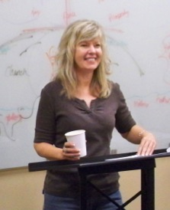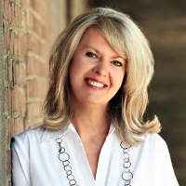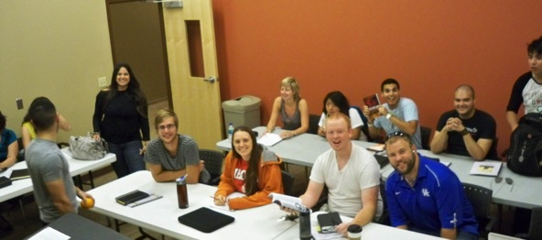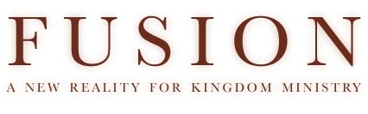 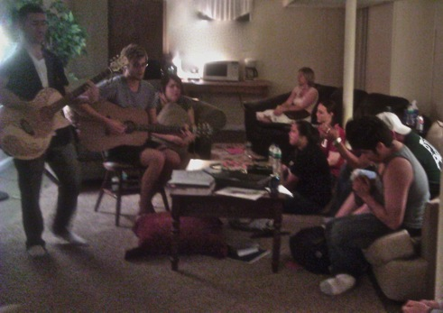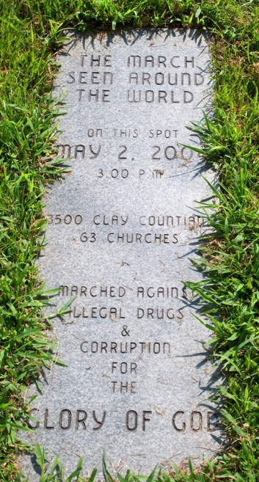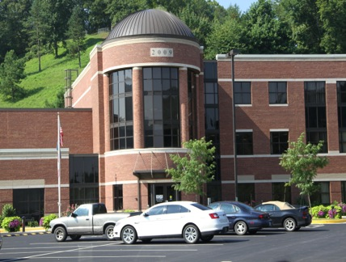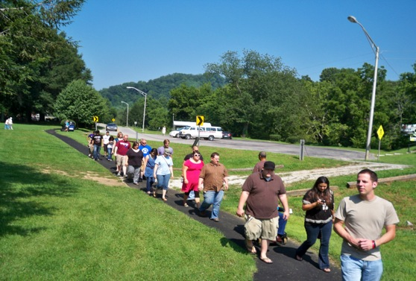 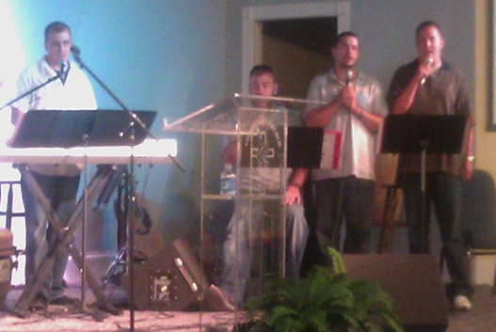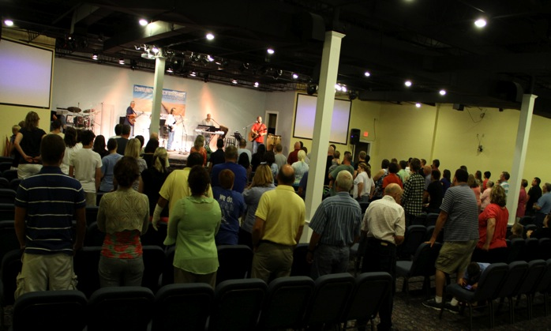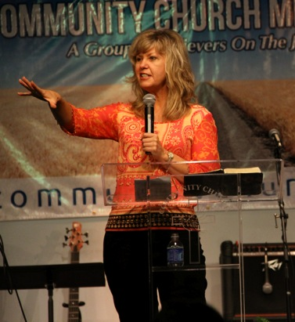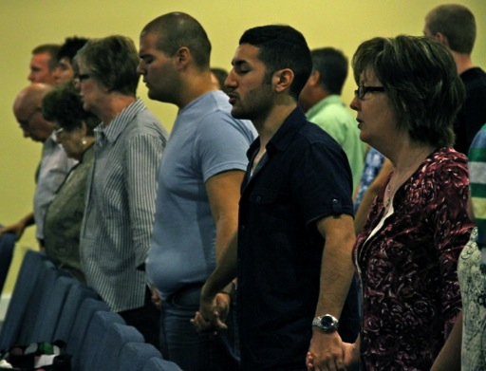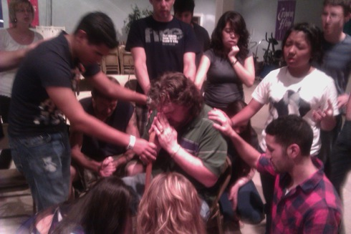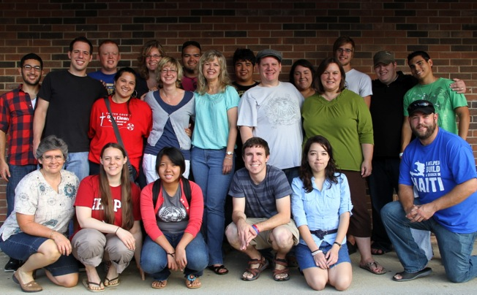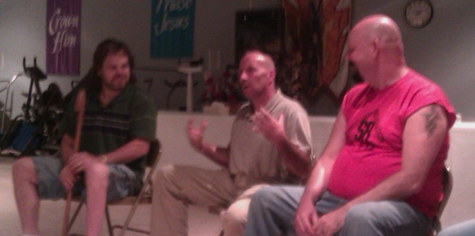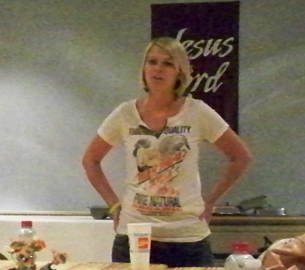

Our Summer Transformation Intensive in July was so incredible. It was an amazing time, a highlight of my 17 years of ministry to be honest.

The first week we spent in Kansas City laying foundation of teaching in Gods word regarding supernatural community transformation and redemption. We spent a lot of time building the team through small groups, extended time in prayer and worship and in the prayer room. In a couple of days the team became united in love and purpose. The Lord quickly began to transform our hearts and lives.

By the end of the week we were a team prepared for a week of ministry in Manchester. The Lord prepared our hearts to serve Manchester from a place of corporate identity and humility. We laid down our individual gifts and agendas and the Lord “sowed us into the land” (Hos 3). As a result we were able to bless and serve the people of Manchester by hosting the presence of the Lord together with them.

The exciting part is the two-week intensive wasn’t the end of something but the beginning of on-going ministry in Texas this Fall on campuses and along the border. The Lord has more in mind for this team in the days ahead! Thank you Jesus!

With a grateful heart,

*Rhonda*

*Intensive Transformation Class in Kansas City!*

Our participants were leaders in houses of prayer, university campuses, marketplace, a hospital, education, etc. They are spiritual revolutionaries that want to see God’s Kingdom come where they live!

Our intensive class met at IHOP-U every day for teaching on the Biblical foundations of transformation. The class was so perceptive and digested an enormous amount of teaching!

Wes Adams joined us teaching two mornings sessions which were powerful! The class received almost 20 hours of teaching on transformation in a week! It was an *intense* intensive!

**August 2011**

The commemorative marker in the park of that historic day! The new Kentucky University branch (right) which soon will offer PhD programs! One of numerous tangible indicators of transformation!

Every evening we spent about 4 hours together eating, fellowshipping and watching transformation DVD’s in my home. These documentaries planted seeds of faith by sharing real stories of God’s redemption in the earth. Some evenings we shared our personal accounts of Guatemala and Fiji which was fun. Wes Adams joined us for the Guatemala night and we shared about our trip there together! We also spent extended time in sweet worship, the Lord came every time. It was some of the most powerful worship and presence of the Lord many of us have ever experienced! Jesus enjoyed the intensive too!

***Visiting a Manchester – A Transformed Community!***

Our team walking out to the park where the march ended in the rally where 64 pastors repented. That day the presence of God enveloped His people and the transformation of the community exploded soon after.

Local worship leaders, singers and musicians were on the team with our team. By Friday night the pastors decided to continue the meetings! Manchester now has a house of prayer expression with local teams leading the community in prayer and worship every Friday night!

Each evening before the service we trained teams in harp and bowl prayer & worship and we had ministry teams available for personal prayer appointments. The services focused on presence-focused worship and preaching God’s Word about building His dwelling place of prayer and presence in the community. People were touched and impacted by the presence of the Lord and the call to renewed devotion.

These are guys from Chad’s Hope, the drug rehab center learning Harp & Bowl worship! They were amazing and so excited as the Lord anointed them to lead worship. The whole room erupted in rejoicing! Most of the participants also came for personal prayer ministry as well. Our team also went out to Chad’s Hope and spent the morning worshipping with them and praying for them! It was one of the highlights of the week for sure!

The Encounter God services in Manchester were amazing! The presence of the Lord was so tangible. Tuesday night the glory of God filled the sanctuary! Nobody wanted to leave that night, it was incredible! Spiritually hungry people drove from hours away to attend, every night the Lord lead us and met us!

http://www.facebook.com/n/?video%2Fvideo.php&v=1706616885648&mid=4a4aeadG214c52aeG9768c12G1d&bcode=AzW2cifu&n_m=rhonda%40fusionministry.com

Steve Collett (featured on the Appalachian Dawn DVD) (center) shared with us one day and Melanda Adams(from the DVD as well) met with us as well. These were powerful afternoons!

Our team prayed for Dave (right), a former drug dealer who was partially paralyzed from being shot 6 times. His story of redemption was stunning. As we prayed, his paralyzed left foot began to move! He was shocked and began to walk on it. We all went nuts praising the Lord as he walked on it for the first time in 6 years! In a quiet voice filled with awe he said “the Lord has already blessed me so much, it never occurred to me to ask Him for more”. We were amazed.

***The Glory of Redemption in Transformed Lives!***

Our team – changed forever!

Here is a powerful song called the “Eagle Song” one of the leaders of the Terre Haute house of prayer wrote that really captures what the Lord did in our Intensive.

Click here to listen (2 minute clip):

***Upcoming Events***

**September 9th – 11th** – Laredo, TX

Transformation Conference & Leadership Consultation with leaders from Laredo and several communities in Mexico. Launching “Face to Face” consecration for multiple communities.

**September 12th** – Houston, TX – University of Houston

Preparing campus ministries, congregations and houses of prayer for “Face to Face” consecration process this fall.

**September 13th** – Austin, TX - University of Texas

Preparing campus ministries and houses of prayer for “Face to Face” consecration process this fall.

**September 22nd – 26th** – Weslaco, TX

“Rio Grande Valley Transformation Conference” and Leadership Consultation for several communities along the border and “Face to Face” consecration launch for several congregations.

***Get Involved!***

The Lord has invited us into a very exciting season. Our hearts are committed to be obedient to everything He has set before us and we are believing God for much fruit and breakthrough in the months ahead! Would you prayerfully consider becoming a ministry partner with Fusion? We can’t do this alone, we need friends to partner with us in prayer and financial support.

To support our ministry click on “Support”on the website or send a check payable to “Fusion Ministries”:

Fusion Ministries, Inc.

721 Main Street, Suite 105, Grandview, MO 64030

Website: [www.Fusionministry.com](http://www.Fusionministry.com)

Blog: Fusion4revolution.blogspot.com

Follow “Fusion Ministries, Inc.” on Facebook!