

**June 2011**

**Manchester, “City of Hope," Kentucky!**

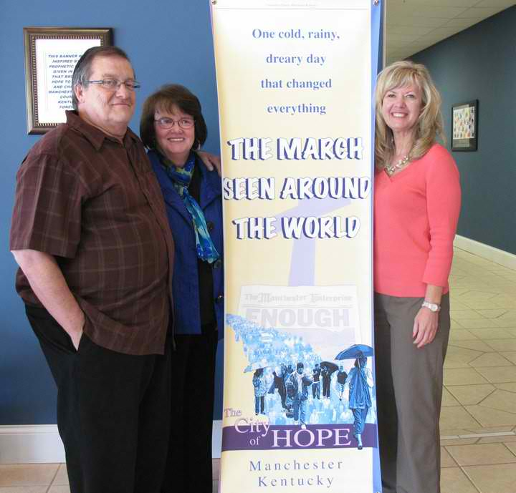

**Doug and Linda Abner and I standing by the banner marking the catalytic march**

**that led to the transformation of the community of Manchester, KY**

For the past seven years this small community of 2,200 has been interviewed by dozens of news agencies, their story appearing on CBN, MSNBC, CNN, The Associated Press, Nightline, etc. Hundreds of people have been traveling uninvited to see what the Lord has done and thousands have watched the story on the transformation documentary “Appalachian Dawn” (produced by the The Sentinel Group).

I finally had the opportunity to visit Manchester to experience the transformation for myself. After 11 years of laboring in our nation for transformation I was not disappointed! Many of us have wondered if this day would ever come – could the United States experience supernatural, presence-based transformation?

Many believers have said “no”. Some are just totally uninterested. Other have insisted God was going to “do it differently here”, an unveiled refusal to avoid the process of abandoning ourselves in humility, intimacy and repentance that God requires.

The Manchester, Kentucky story is a powerful testimony that embodies the same characteristics and process of transformation that has occurred in the non-western world. God required the same from the people of Manchester as He has from every other community that has attracted His transforming presence – to humble ourselves, seek God’s face and turn from our wicked ways. Then, the Lord promises “I will hear your prayer, forgive your sin and heal your land” (2 Chron. 7:14). They were desperate and in their desperation they cried out to the Lord and abandoned themselves to the transformation process.

God hasn’t given up on our nation and He has proven that to us in the testimony of Manchester, Kentucky. If God can do this in Manchester – there is hope for all of us!

**Why You Should Care About the Manchester Story**

While transforming revival has been sweeping across the nations impacting hundreds of communities in the 21st Century, the western world has been virtually untouched by it’s reality and power.

Over the past decade we have heard the reports, watched the documentaries or maybe visited the communities that were transformed. First, 8 communities were documented as being transformed, then the number quickly hit 50, then 150 and still no transformation in the Western World. The number of transformed communities reached 300, then 500 just a couple of years ago. Still we waited and wondered…when would *we* experience the reality of transforming revival?

In the first decade of the 21st Century, over 800 *communities in 45 nations* have now been impacted by the fire of transforming revival! In that same decade the Western World has one stunning example – Manchester, Kentucky.

God has done a supernatural work in Manchester – nothing any man or ministry would or could take credit for. It is the first-fruit of more transformation to come in our nation. Once transformation occurs it provokes surrounding communities to jealousy and faith and the presence of God becomes sought-after and presence contagious!

That’s why you should care about Manchester. We must partner with God in intercession and posture our hearts in humility and engage our hearts in faith in this important time in our history!

Take a moment to read the brief account of what happened in Manchester, order the full DVD story and watch it with friends, then pray and seek the Lord for how He would have YOU respond to prepare YOUR community for His restored presence and blessing!

**The Manchester Story**

A small, isolated community in the Appalachians, the city of Manchester, Kentucky, seemed to be an impossible candidate for transformation. Many considered it beyond hope. In 1964 CBS news report gave Manchester the dubious distinction “Depressed City, USA.”

Forty years later, things had only gotten worse in Clay County, being listed as the sixth poorest county in the United States. In addition to its poverty, its violent image has been widely renowned. In a TV exposé by the History Channel on Clay's family feuds, it was reported that four local clans killed more than ten times the number of family members than those killed in the infamous Hatfield and McCoy rivalry.

In addition, the community was steeped in systemic corruption for more than 200 years resulting in violence and feuding, leading to the nickname “Gun Chester”. Healthy, functional families and community life were virtually non-existent. Sixty percent of the people were drawing government aide and there were more people residing in prison than people residing in the county seat.

Clay County had more unsolved murders than any county in Kentucky. It was also one of 10 poorest school systems in the nation and the bottom in the state of Kentucky. In addition, the police department was full of corruption; there was systemic corruption in the court system and apathy ruled in the church, which was intimidated by the darkness.

When drugs were introduced to Clay County things spiraled out of control. When meth addiction led to oxycontin addiction, it was the tipping point. Soon most of the community was involved in using, dealing or stealing to support the addiction. They were losing 1-2 young people every week to drug overdose. Because city and county officials were involved, the drug trafficking was unchecked and in the open which made Clay County a safe place for both users and high-level drug dealers.

In 2001, the Drug Enforcement Agency included Manchester in a region listed as the “Painkiller Capital of America.” The community was devoid of all hope.

As Pastor Doug Abner shared the “problem wasn’t the darkness it was the lack of the light”. Church didn’t do anything about the problem because they were afraid and intimidated and lacked unity and purpose.

**Breakthrough – A Revived Church!**

In late September 2003 desperation began to boil over in the community. People started approaching the pastors appealing to them to “do something!”. In their desperation the pastors began praying Saturday mornings. At first only 10-20 people came but then it increased until sometimes over 100 people would gather to cry out to the Lord for His intervention.

By early 2004 the Lord began to respond in a surprising way. Simultaneously, as the pastors began to pray, the Lord began to speak to other leaders. A congressman from Kentucky formed a new drug enforcement organization called “Operation Unite”. Soon, 50 undercover cops were dispatched to Clay County and began to target the community to arrest drug dealers and provide counselors in high schools and other drug treatment programs.

Prayer intensified and pastors began to take responsibility for the condition of the community and repent to the Lord. As they prayed, the Lord began to give pastors who were praying His strategy for breakthrough.

In May 2, 2004, 63 churches and 3,500 people united together as community say “ENOUGH” and take their stand against drugs. Like troops advancing upon a city, believers joined together under the direction of church leaders who publicly repented before GOD for their lack of civic involvement. Suddenly, a pulse could be felt; hope had been resuscitated. Many felt this climactic prayer event helped break the vice-like grip of drug addiction that had tormented daily life.

At the rally, 63 pastors asked the Lord to forgive them for their focus on their individual programs and buildings, for their division and competition. The pastors got on their knees and prayed and the presence of God filled the park. Some people reported the atmosphere was so saturated by the presence of the Lord they could hardly breathe, many were weeping. They felt the battle turn and they sensed God’s pleasure.

The following Monday, the pastors gathered in teams and visited every county official and repented to them saying “would you please forgive us for not being the church?” They then prayed for each one of them!

Immediately the Lord began to answer the prayer! The following Thursday Operation Unite arrested 50 drug dealers. Then, they asked the pastors to join them and talk to dealers about the Lord. The church formed a new partnership as the Lord began to uproot the kingdom of darkness and bring His kingdom of light!

**Transformation of Community!**

As the church continued to pray, testimonies increased, lives were being impacted and changed. Hope began to fill and impact the lives of people! Local drug dealers soon began surrendering their lives to Jesus and getting delivered from drug addiction.

The atmosphere began to change, people started getting saved and the congregations began to grow. Filled with new hope, creative ideas began to flow, dreams were rekindled and joy and peace filled the hearts of the people.

The new life reviving the congregations fueled the faith of the pastors who were praying. They began to get involved in the community. They began to pray for the schools, in the classrooms, for the school board, even participating in their meetings.

The churches also partnered together with law enforcement to root out crime and corruption. A court watch program was initiated by the churches to ensure justice in the courts, and with the help of their Congressman, a Christ-centered rehabilitation center was completed in 2008 paid or by government funds!

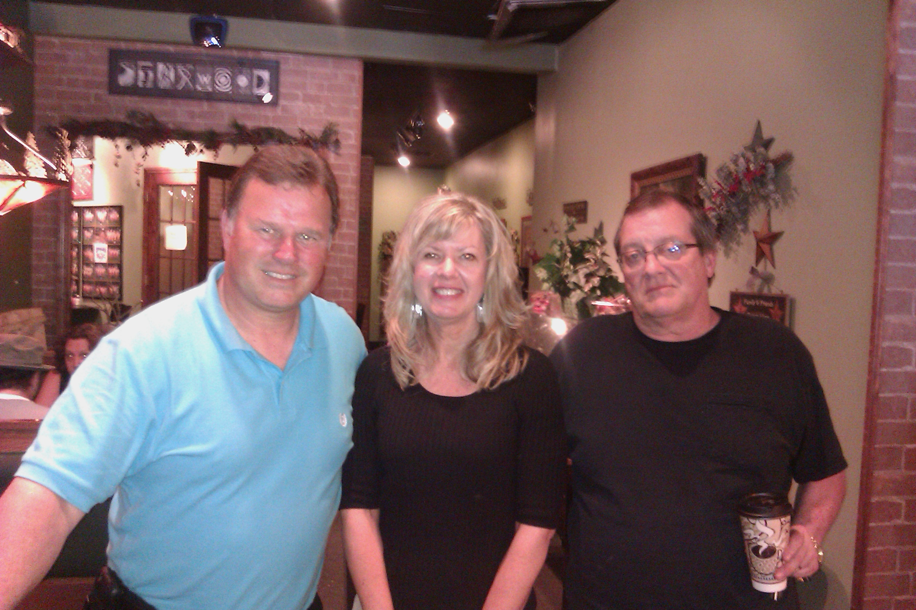

Paul Hays, the former Post Commander for State Police in Eastern Kentucky and current leader in “Operation Unite” and Pastor Doug Abner.

According to Sheriff Kevin Johnson, the church partnership with the police was “the best thing to happen to Clay County.” Furthermore, this uncommon collaboration, “Operation Unite,” has become the model for the entire state. As a result, this obscure community has become a regional influence, receiving desperate calls from 49 different states, and five foreign nations, all soliciting Clay County for guidance in their battle against drugs.

The vast majority of all elected officials are now believers. High-ranking officials like the new mayor and the sheriff to begin advancing the kingdom cause of Christ in their respective spheres of influence.

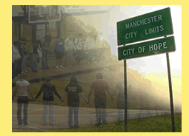Consequently, in 2007, the new mayor made her first order of business to show a 700 Club report about Manchester and then declared Manchester the “city of hope”. The city council then voted to officially change the name of the city to “Manchester: City of Hope”!

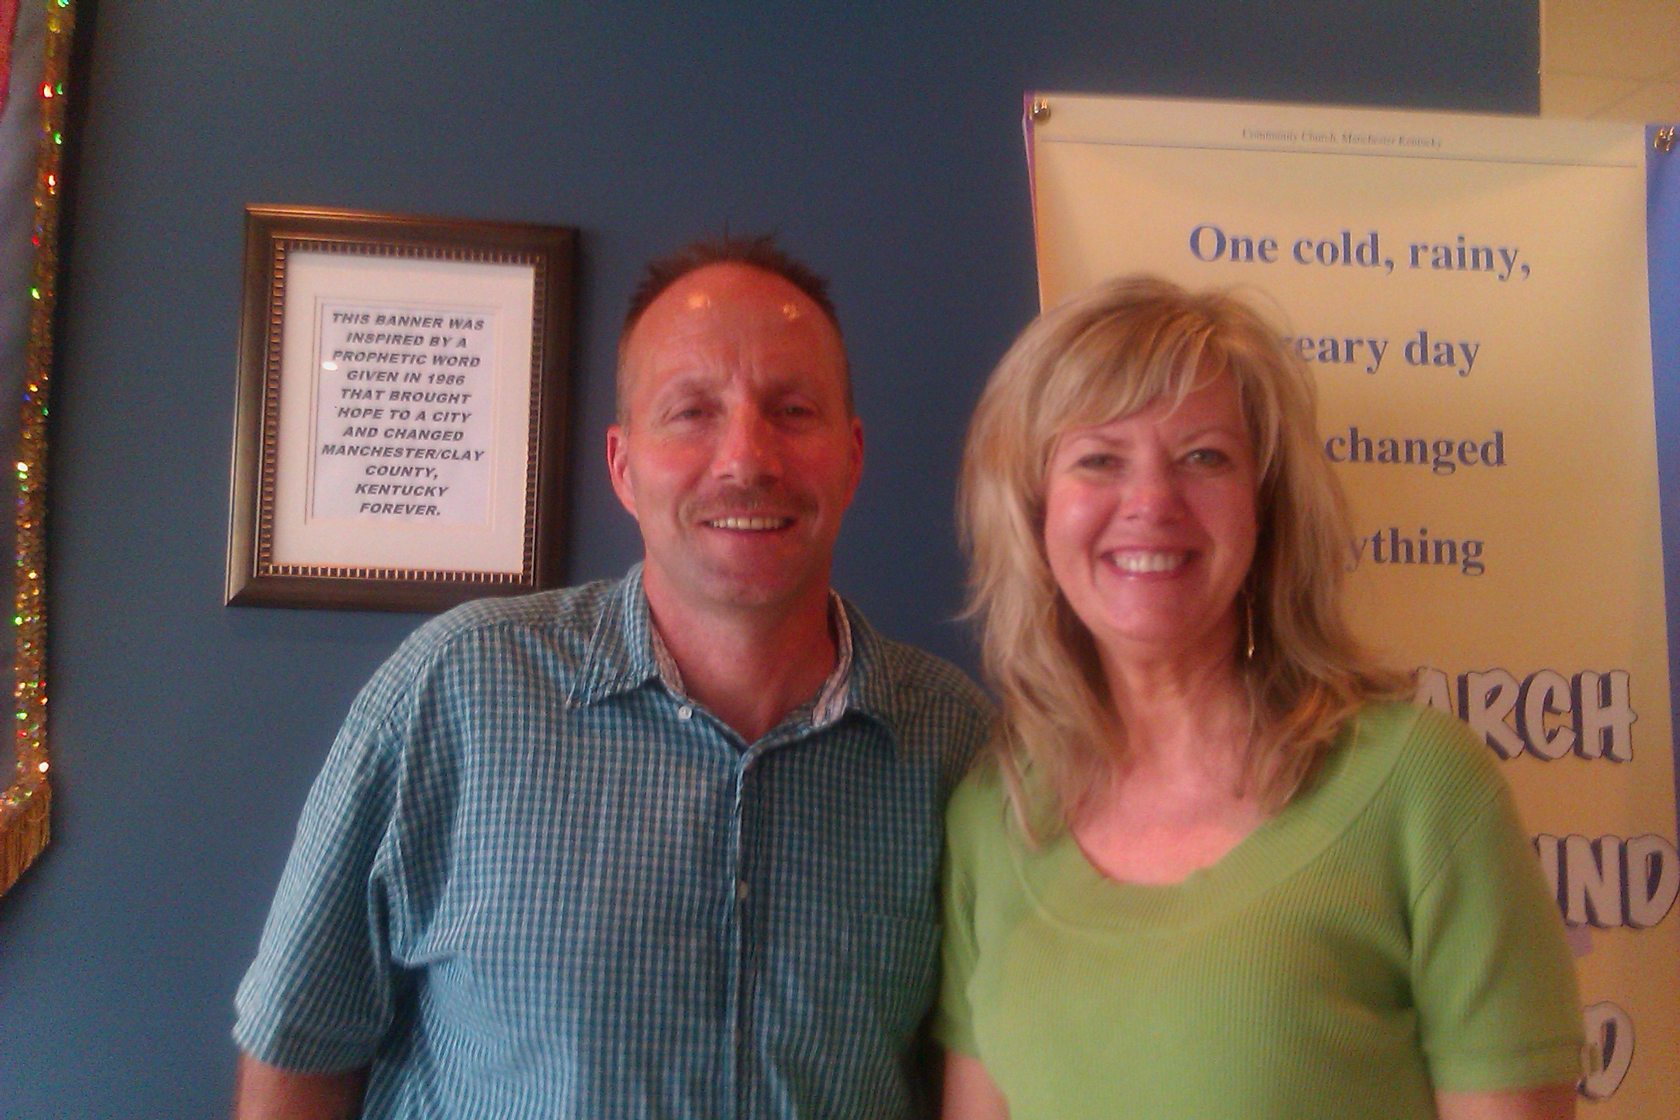

Steve Collett, former “most miserable human being on the planet” and former drug dealer. Now gloriously redeemed and bringing many into the kingdom!

At the one year mark after the march, pastors asked the Lord to expose all the darkness in the city and within days, 100 FBI agents and the Drug Enforcement Agency showed up in the Manchester and quickly arrested 17 high-level drug dealers. Drug arrests increased by a staggering 300 percent with a 95% conviction rate. Over 3,000 people were arrested in Clay County, 800 in Manchester alone and sent to state prison or rehabilitation.

The following year, Manchester became the only area in the region where painkiller prescriptions actually decreased.

The sting operation also caught high-level officials in its investigation. Within three years over 60 people would be exposed and jailed for racketeering, distributing drugs, voter fraud and go to prison. These included: the former Mayor, city councilmen, the 911 Director, the Asst. Chief of Police, the Fire Chief, the City Manager, Circuit Court judges, the School Superintendent, school system employees, and others.

Consider this AP report on 3/11/11:

“Two former officials have been sentenced to decades in federal prison for conspiring with a former judge, school superintendent and others to gain power and control politics in an eastern Kentucky county. U.S. District Judge Danny Reeves in Frankfort handed down a 293-month sentence to former Clay County School Superintendent Douglas C. Adams and a 150-month sentence to 47-year-old Freddy Thompson, the former county clerk, on Wednesday. The men were part of a group of eight officials convicted in March of multiple charges, including racketeering, money laundering and voter fraud stemming from the 2002, 2004 and 2006 elections. Reeves on Tuesday handed down 20-year sentences to two other men in the scheme.”

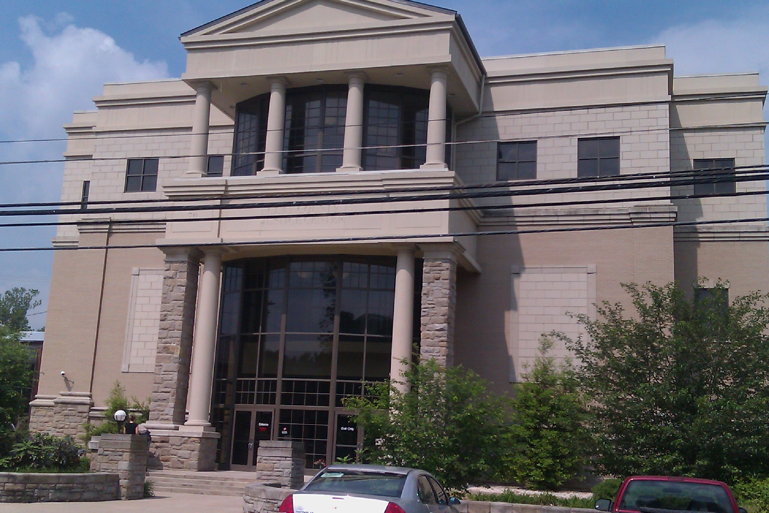

**The New Clay County Justice Center!**

Transformation has not only occurred in the lives of people and the congregations, it has impacted the city and civil government and the education system as well!

Students are now being drug tested in school, Bible elective courses are being offered in high school. In addition, Clay County was chosen as having the model-reading program for children in the state in 2008, significant for a region traditionally plagued with high illiteracy rates.

God’s transforming work is also evidenced in the healing of the water. Before, the water always needed to be filtered to be drinkable, but in 2008 the water of Clay County won first-place in municipal water system in the state! In fact, the local water treatment plant is now selling “Hope Water” as a commercial product.

Last, but not least, Clay County now possesses one of the largest elk populations in the country; and turkey, bear, and deer populations are making a comeback following generations of having almost no presence in the area.



To order the “Appalachian Dawn” transformation DVD click here: <http://shop.fusionministry.com>

This story will inspire you to believe God for all He longs to do in your community

Click here for the movie trailer: <http://www.glowtorch.org/Home/AADwbanner/tabid/2731/Default.aspx>

**Partner with Us!**

The Lord has connected our hearts to the leaders in Manchester. We have been invited into the community to teach, meet with leaders around the region and provide resources to help them as they carry the fire of transformation to the communities around them. What a joy and privilege to serve them!

Would you prayerfully consider becoming a ministry partner with Fusion and sowing into the Kingdom activity the Lord has set before us? Contributions are tax-deductible and can be sent to:

Fusion Ministries, Inc.

721 Main Street, Suite 105, Grandview, MO 64030

Website: [www.Fusionministry.com](http://www.Fusionministry.com)

Blog: Fusion4revolution.blogspot.com

Fusion Ministries, Inc. is now on Facebook!