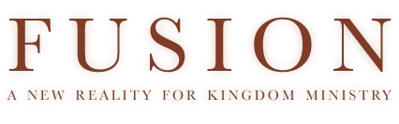

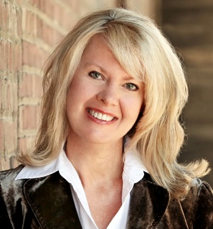
Greetings! We have had a busy summer I can’t believe how quickly things are happening both in the natural and the spiritual. These are intense days but exciting days!

I’ve been ministering quite a bit in Texas this summer, serving campus ministries and ministering in communities along the border of Mexico. This weekend, our Summer Transformation Intensive is beginning to train young adults to impact their communities for transformation. We also are getting more involved in consecration on University Campuses and just released our promo video for the “Face to Face” process (see link below). It’s powerful!

I want to invite you to partner with us in prayer regarding this new season for Fusion Ministries. Consider joining our prayer team, sowing into the ministry to support us financially or even consider becoming a trumpet for consecration in your own community!

It’s time to prepare the way of the Lord. He is drawing near to His bride, let’s respond with wholehearted abandonment until our nation is filled with His glory!

With an expectant heart,
Rhonda Hughey
Director, Fusion Ministries

Rio Grande Valley, Texas
June 2011

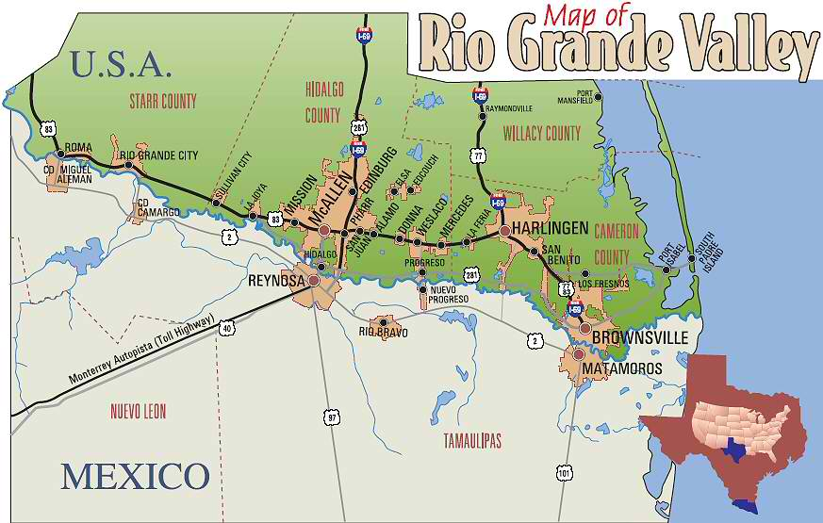
Weslaco
Weslaco is deep in the Rio Grande Valley, almost to the southern tip of Texas, near Brownsville. I visited this area in June and was blessed to find dozens of communities connected, praying and desperate for God’s transforming presence!
The first evening we had a combined service with several hundred hungry people from all over the Rio Grande Valley! I shared the hope of transformation and the Lord gave me a prophetic declaration about His coming as a Redeemer to the Valley! It was a powerful night.
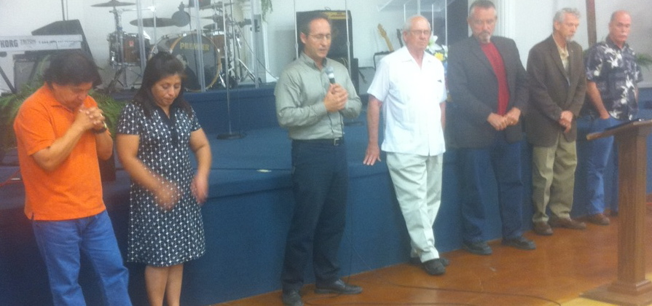
I showed the clip of the Manchester transformation testimony and it was extremely powerful because of all the parallels of corruption, violence and drugs in the Rio Grande Valley.
Pastors responding to the message
The following morning, I met for several hours with pastors and leaders from all over the Rio Grande Valley. Within a couple of hours, they knew the Lord was confirming to them they were ready consecrate themselves and begin the journey toward transformation this fall. Not only have they committed to go through in their communities, they are carrying the hope of transformation and the process of consecration out to many other communities in the Rio Grande Valley! They have also committed to a full conference this September.
The morning of the leadership consultation the sky was filled with dark clouds. But the pastor said the black clouds come across every morning but “they never release rain”. It hadn’t rained in Weslaco for 6 months. I began to intercede and told those clouds to release the rain over the city!
I received news Wednesday that it started to rain and it rained for 3 days. The drought was broken. I believe this is a clear encouragement to the pastors to pursue 2 Chron 7:14 - the Lord can open the heavens!
Laredo
Laredo – Laredo is the “north gate” of the Rio Grande Valley. The border between Texas and Mexico has become a war-zone. While we get very little news in the USA about what is happening, it doesn’t take long to realize how terrifying life has become for the people living there when you visit the area.
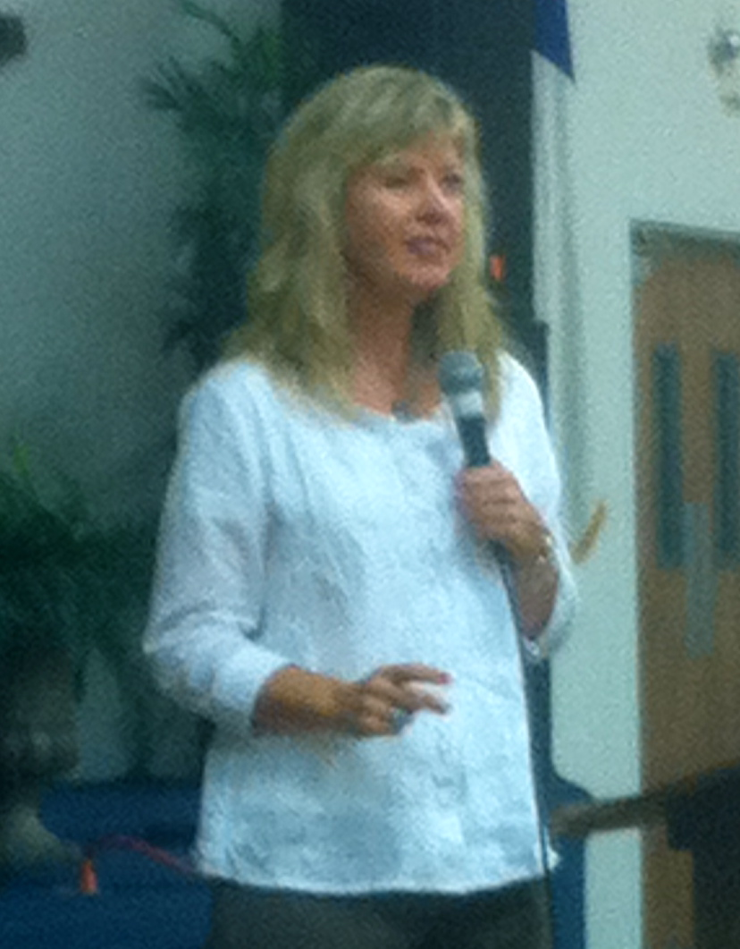
Sunday night we had a citywide gathering and I showed a clip of Manchester, Kentucky and shared vision for transformation for Laredo. Showing the Manchester story in the context of Laredo was powerful because they understand the intimidation, corruption, violence and drugs. The vision and hope for transformation exploded in their hearts!
The next morning I met with several pastors from Laredo, many of whom had waited, believed and prayed for years to pursue transformation just didn’t know how. They knew it was time for consecration and they have already committed to going through the “Face to Face” Divine Experiment this fall as well has hosting a transformation conference.
Since my visit pastors from Nuevo Laredo (across the border) joined with pastors from Laredo and spent an evening hearing the message of transformation. Their response was to gather around the altar and repent to the Lord and one another. Together, leaders from both cities humbled themselves before the Lord and committed to one another. They have also already agreed to go through the Divine Experiment consecration process together across both sides of the border in Nuevo Laredo and Laredo in September.
Jesus wants to breakthrough with His light into the darkness and bring His glory to the Rio Grande Valley! He is raising up houses of prayer (14 new ones this year) along the border, setting watchman on the wall. The Lord is raising awareness and calling many to pray and serve this area of our nation. I believe this is the season when the border is ripe for the transformation!
Campus Leaders Retreat - Austin, Texas
June 2011

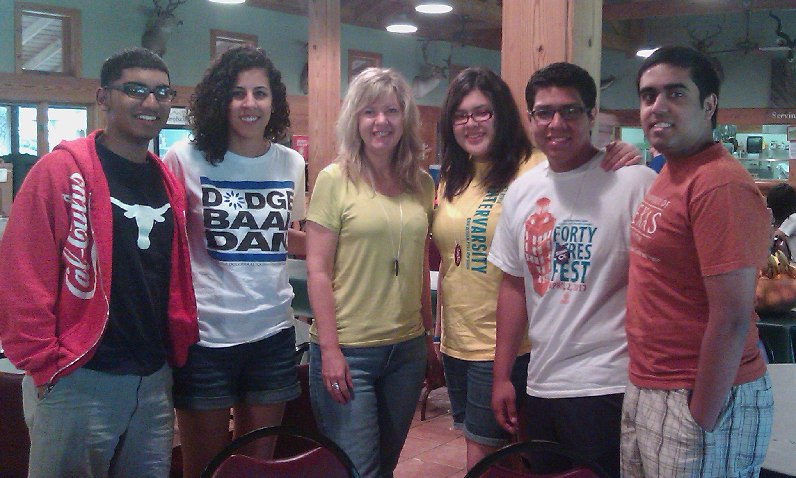

Leaders of the Hispanic chapter of Inter-Varsity

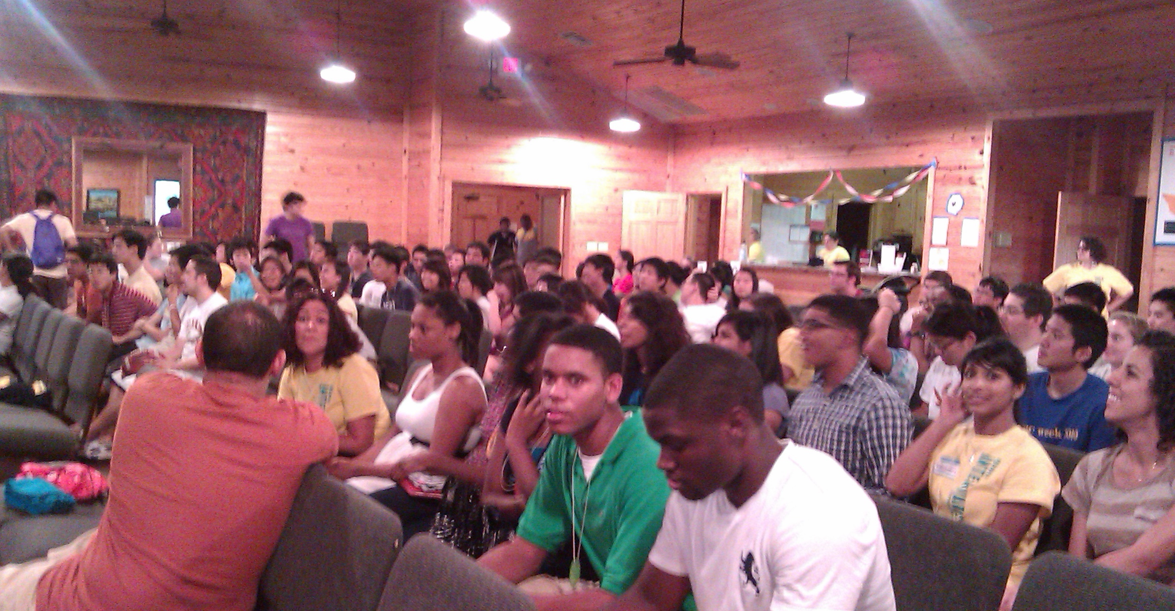
I had the privilege of speaking to the leaders of Inter-Varsity from campuses across the state of Texas at their annual leadership retreat. The Lord is bringing the message of consecration of students on campus to regional and national leaders of the ministry. Several chapters on various campuses will be going through the consecration process this fall!

Evening session at retreat

Watch the A & M “Face to Face” Promo Clip! http://www.thedivineexperiment.com/video-promo.php

Summer Transformation Intensive
July 16th – 31st

Our Summer Transformation Intensive begins this coming weekend! Young adults are joining us from Amsterdam, Orlando, several cities in Texas and Kansas City.

The first week we will focus on teaching the principles of transforming revival in a classroom at IHOP-U. Every day the participants will have time in the prayer room at IHOP. A couple afternoons we will have small group time to process and apply principles to our own personal transformation. Then in the evenings we will watch transformation documentaries and pray together.

The second week the entire team will travel to Manchester, Kentucky to experience transformation first-hand! We will meet with the leaders and people featured in the “Appalachian Dawn” documentary and hear their stories. We will take a tour of the community and see the tangible evidence of the transformation that has occurred.

Then each evening our team, partnering with the team from Terre Haute, will led the community in an Encounter God Service. Those evenings will focus on creating an atmosphere of the presence of God through prayer and worship where people can encounter the Lord and be refreshed in His presence.

In addition, a team from the house of prayer in Terre Haute led by a long-time friend, Marvin Adams will join us to lead worship each evening and to help train singers, musicians and prayer leaders in Manchester to establish a house of prayer! God has much in store for all of us during this intensive, we appreciate your prayers!

Upcoming Events

July 16th – 31st - Kansas City/Manchester, Kentucky
“Summer Transformation Intensive”

September 9th – 11th – Laredo, TX
Transformation Conference, Leadership Consultation with leaders from Laredo and several communities in Mexico & “Face to Face” consecration launch.

September 12th – Houston, TX – University of Houston
Preparing campus ministries and houses of prayer for “Face to Face” consecration process this fall.

September 13th – Austin, TX - University of Texas
Preparing campus ministries and houses of prayer for “Face to Face” consecration process this fall.

September 22nd – 26th – Weslaco, TX
“Rio Grande Valley Transformation Conference”, Leadership Consultation and “Face to Face” consecration launch.

Get Involved!

The Lord has invited us into a very exciting season. Our hearts are committed to be obedient to everything He has set before us and we are believing God for much fruit and breakthrough in the months ahead!

Would you prayerfully consider becoming a ministry partner with Fusion? We can’t do this alone, we need friends to partner with us in prayer and giving so we can

1. To join our prayer team email: Info@fusionministry.com

2. To support our ministry click on “Support”on the website or send a check payable to “Fusion Ministries” to:

Fusion Ministries, Inc.
721 Main Street, Suite 105, Grandview, MO 64030

Website: www.Fusionministry.com

Blog: Fusion4revolution.blogspot.com

Follow “Fusion Ministries, Inc.” on Facebook!

