Ministry Update Fall 2011
FUSION

Fusion Ministries Celebrates Our 10th Year!

This fall, Fusion Ministries celebrates our 10 –year journey of faith in transforation ministry! I’m in awe as I reflect back over the past 10 years at the overwhelming faithfulness of God! Through the years the Lord has used this ministry to change thousands of lives, impact hundreds of communities and several nations. Along the journey, He is working to prove our faith to be genuine thorugh firey trials as we press on in faith for transformation here in the United States. In many ways I sense the past 10 years have only been preparation for the season that is ahead for us. Indeed, this fall we entered into a level of ministry activity we have never experiened and a fruitfulness we have only dreamed about…thank you Jesus for all You have done and all the You have in Your heart for Fusion Ministries in the days ahead!

Spiritual Exodus from the Status Quo!

If there is a common theme of this season it’s a trumpet call to exit from the status quo of religious routine and complacent Christianity! Leaders around our nation, have been prepared in the wildnerness and are ready to lead their people into the reality of wholehearted devotion to Jesus Christ. No more cheap grace! No more compromise! No more self-centered motivation! As campuses and communities prepare for consecration to leave their “Laodecean” culture you can almost feel the ground tremble with the great shifting that is about to take place. A spiritual revolution is at our doorstep! The key to opening the door and crossing the threshold is returning to radical devotion by consecrating ourselves to Jesus and spiritually “detoxing” from the spirit of the age! What waits for us across the threshold? Joy, peace, hope and intimacy with God!

Please take time to read and rejoice over the testimonies of the families, students, campuses and congregations who have been transformed this fall during the “Face to Face” process! You will be encouraged and your faith will be stirred to believe God for all that He has on His heart for YOU and YOUR family and congregation!
www.thedivineexperiment.com
Rhonda Hughey
University of Texas – Austin
I had the joy of speaking at the launch of the first “Face to Face” process at UT in Austin. A student leader from Texas A & M joined me and shared what God had been doing at A & M and that was a powerful exhortation! Almost 300 students went through this first time! The testimonies are amazing! This is the second major university in Texas to go through the consecration process! This was a life-changing and historic event for UT and hopefully the first of many students returning to radical devotion to Jesus!
www.

Consecration on University Campuses!
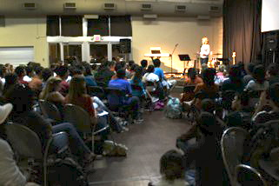

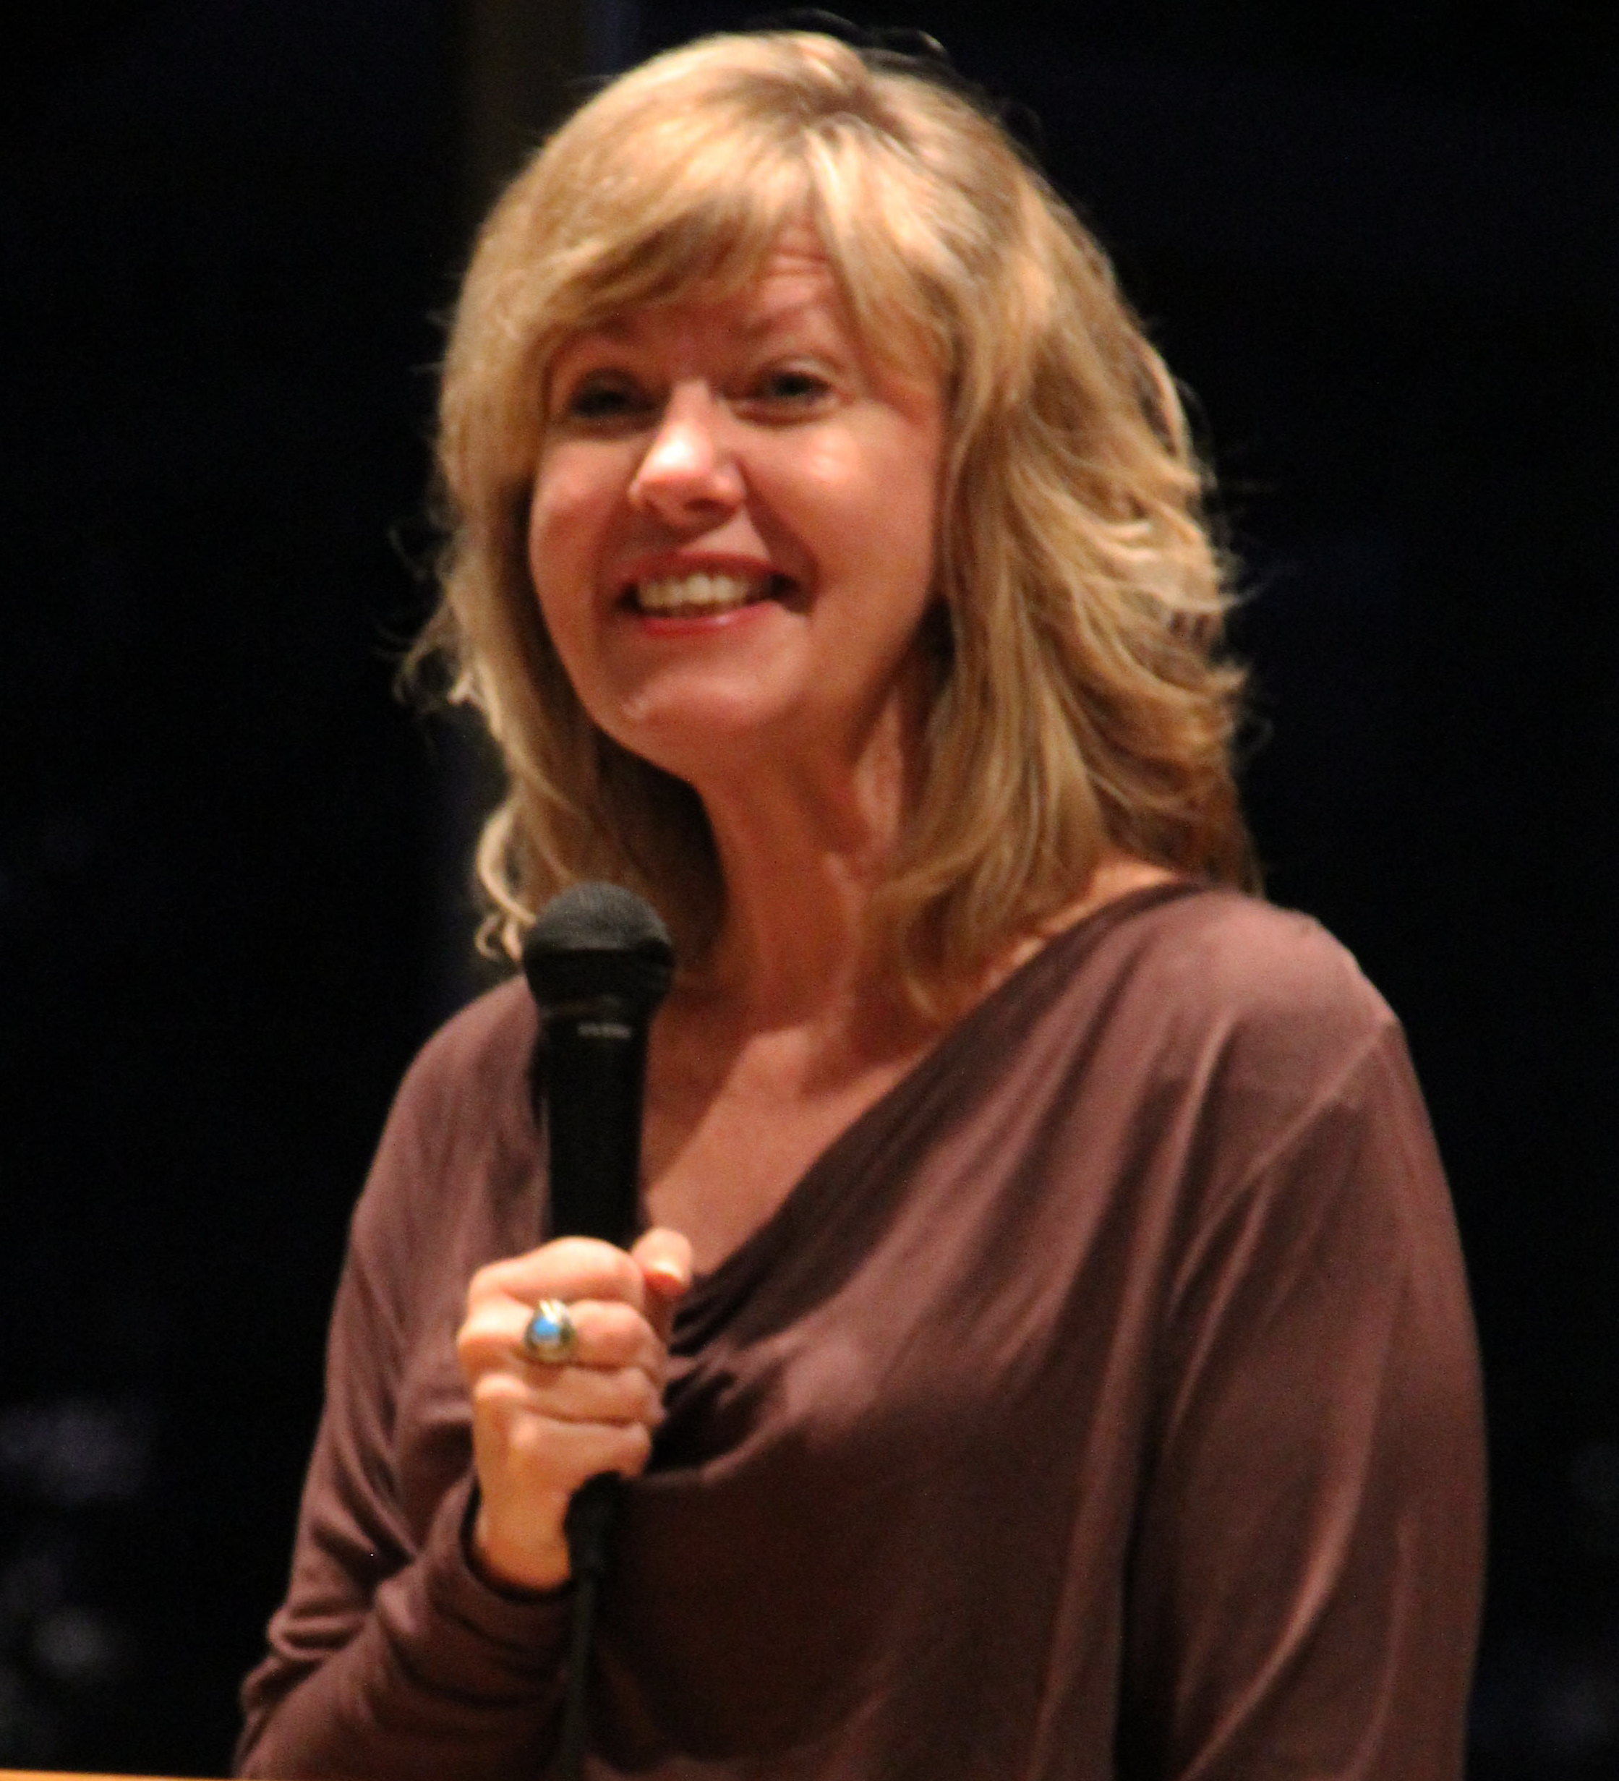
Texas A & M University – College Station, TX
This fall Texas A & M went through their 2nd consecration process with another 200 students! This time the process went much deeper and students really had “Face to Face” encounters with Jesus! A great team of ministry leaders (bottom right) are now praying/worshipping together regularly at the house of prayer on campus! The Lord now has a dwelling place on this campus and you can sense His manifest presence in the chapel! Promo video click here: http://www.thedivineexperiment.com/video-promo-video.php

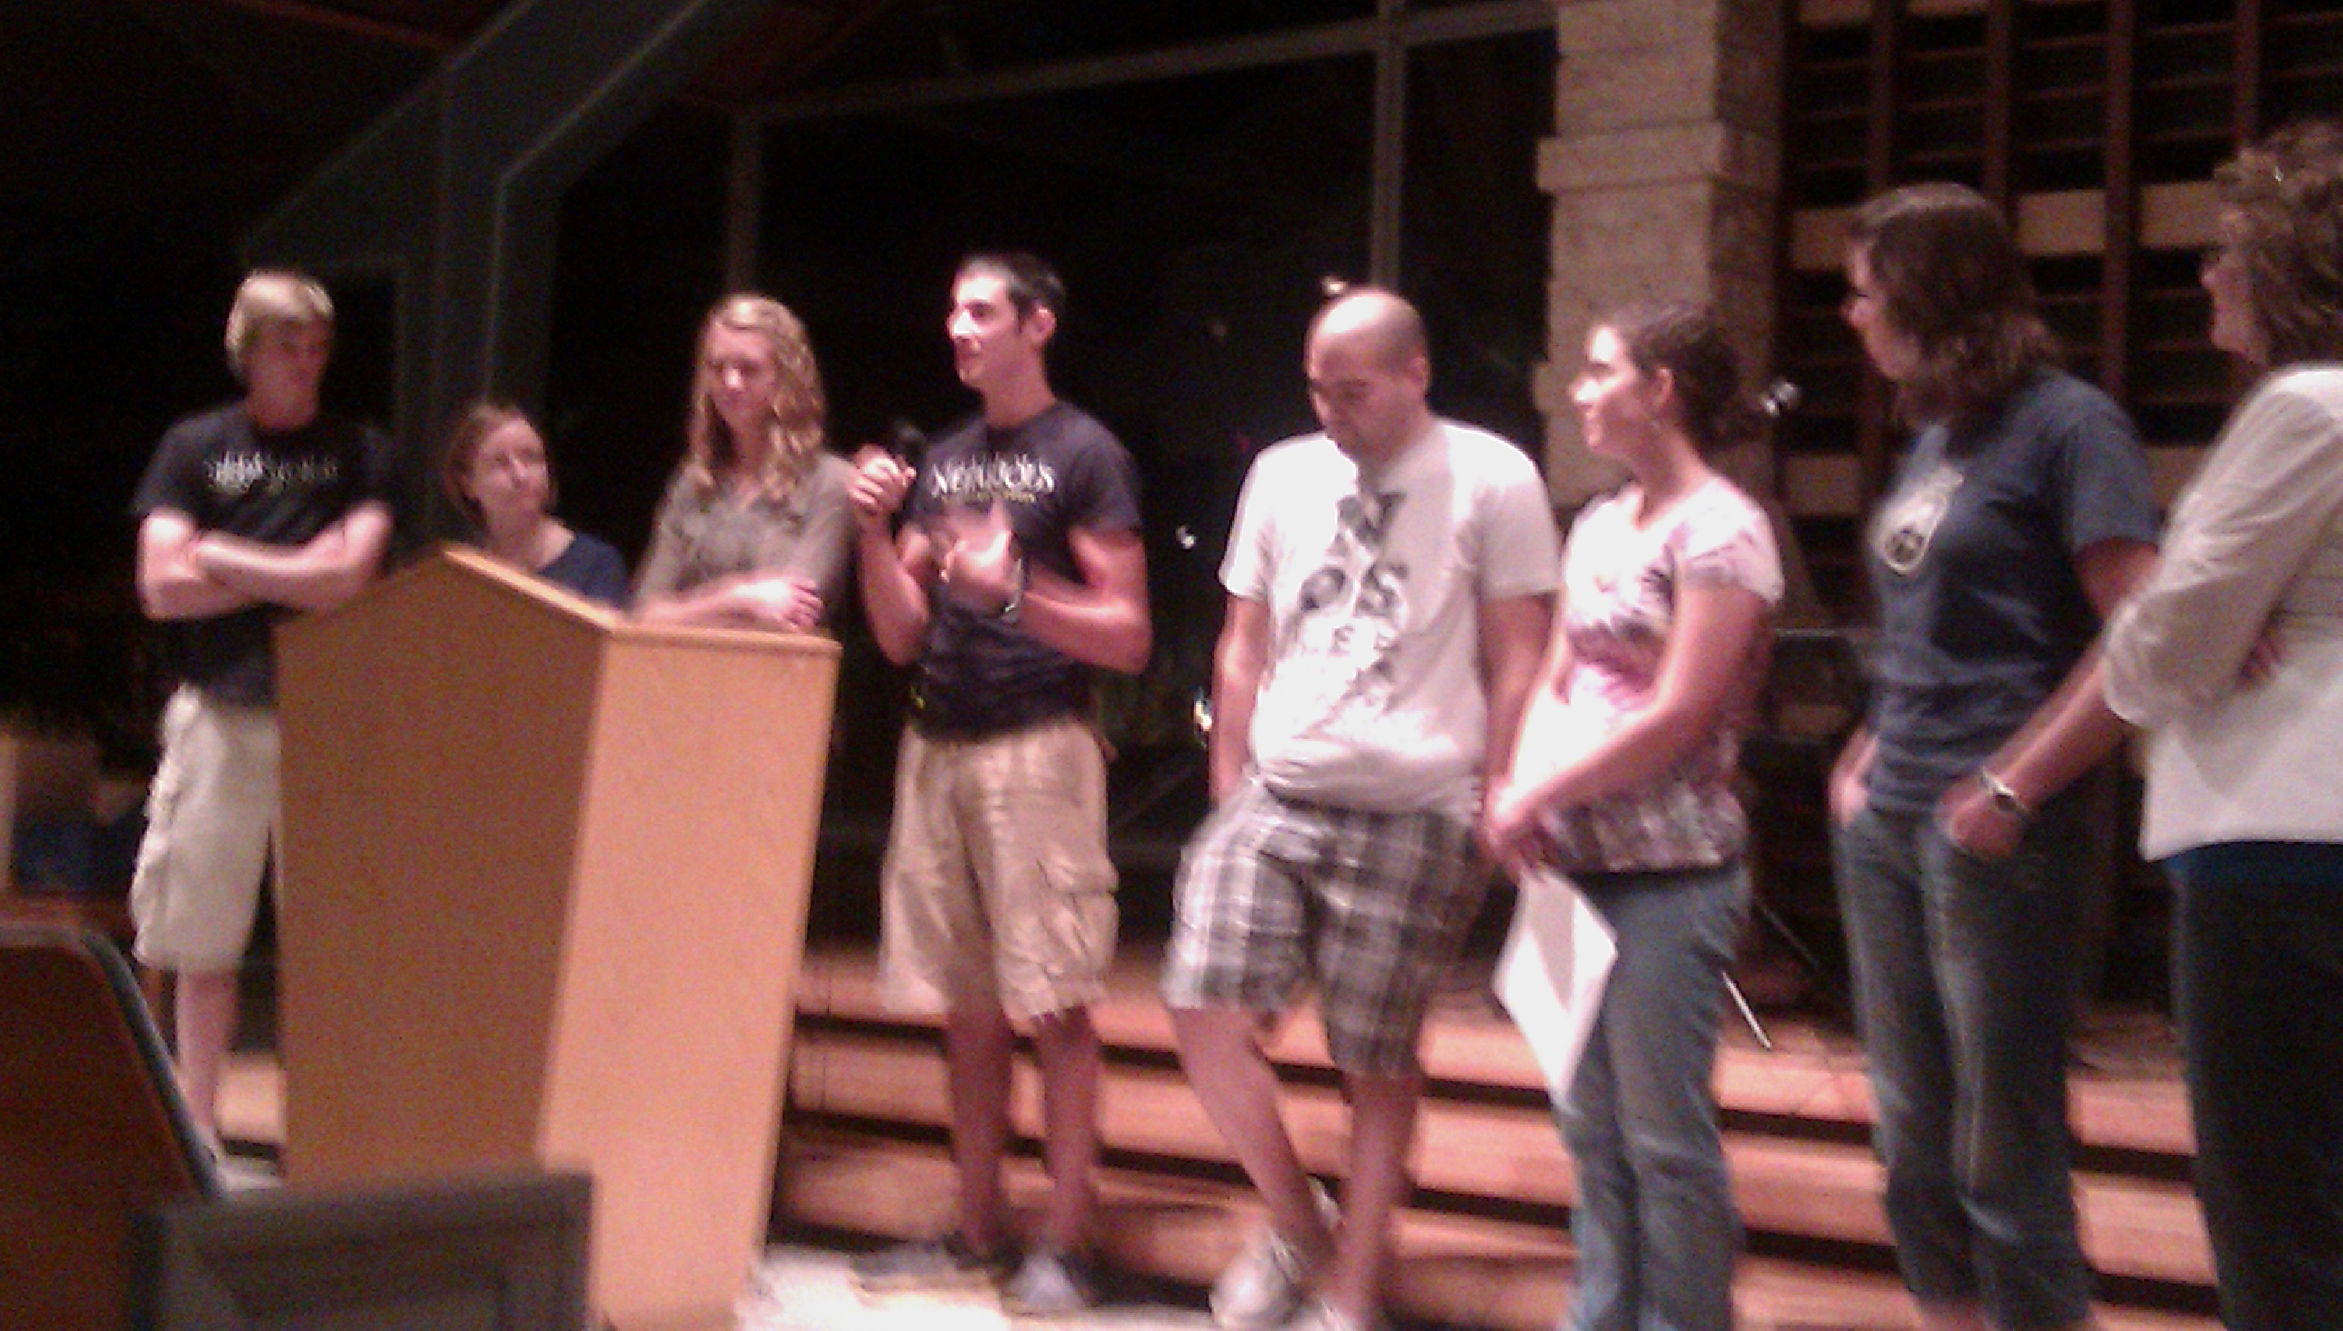
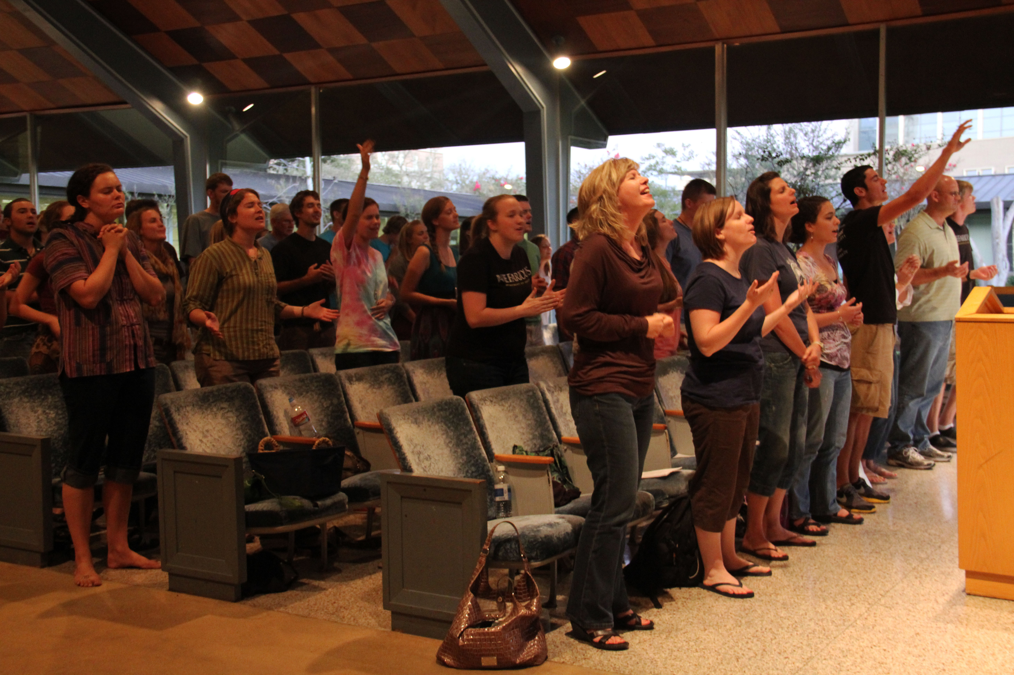
Transformation Conference on the
Mexican Border

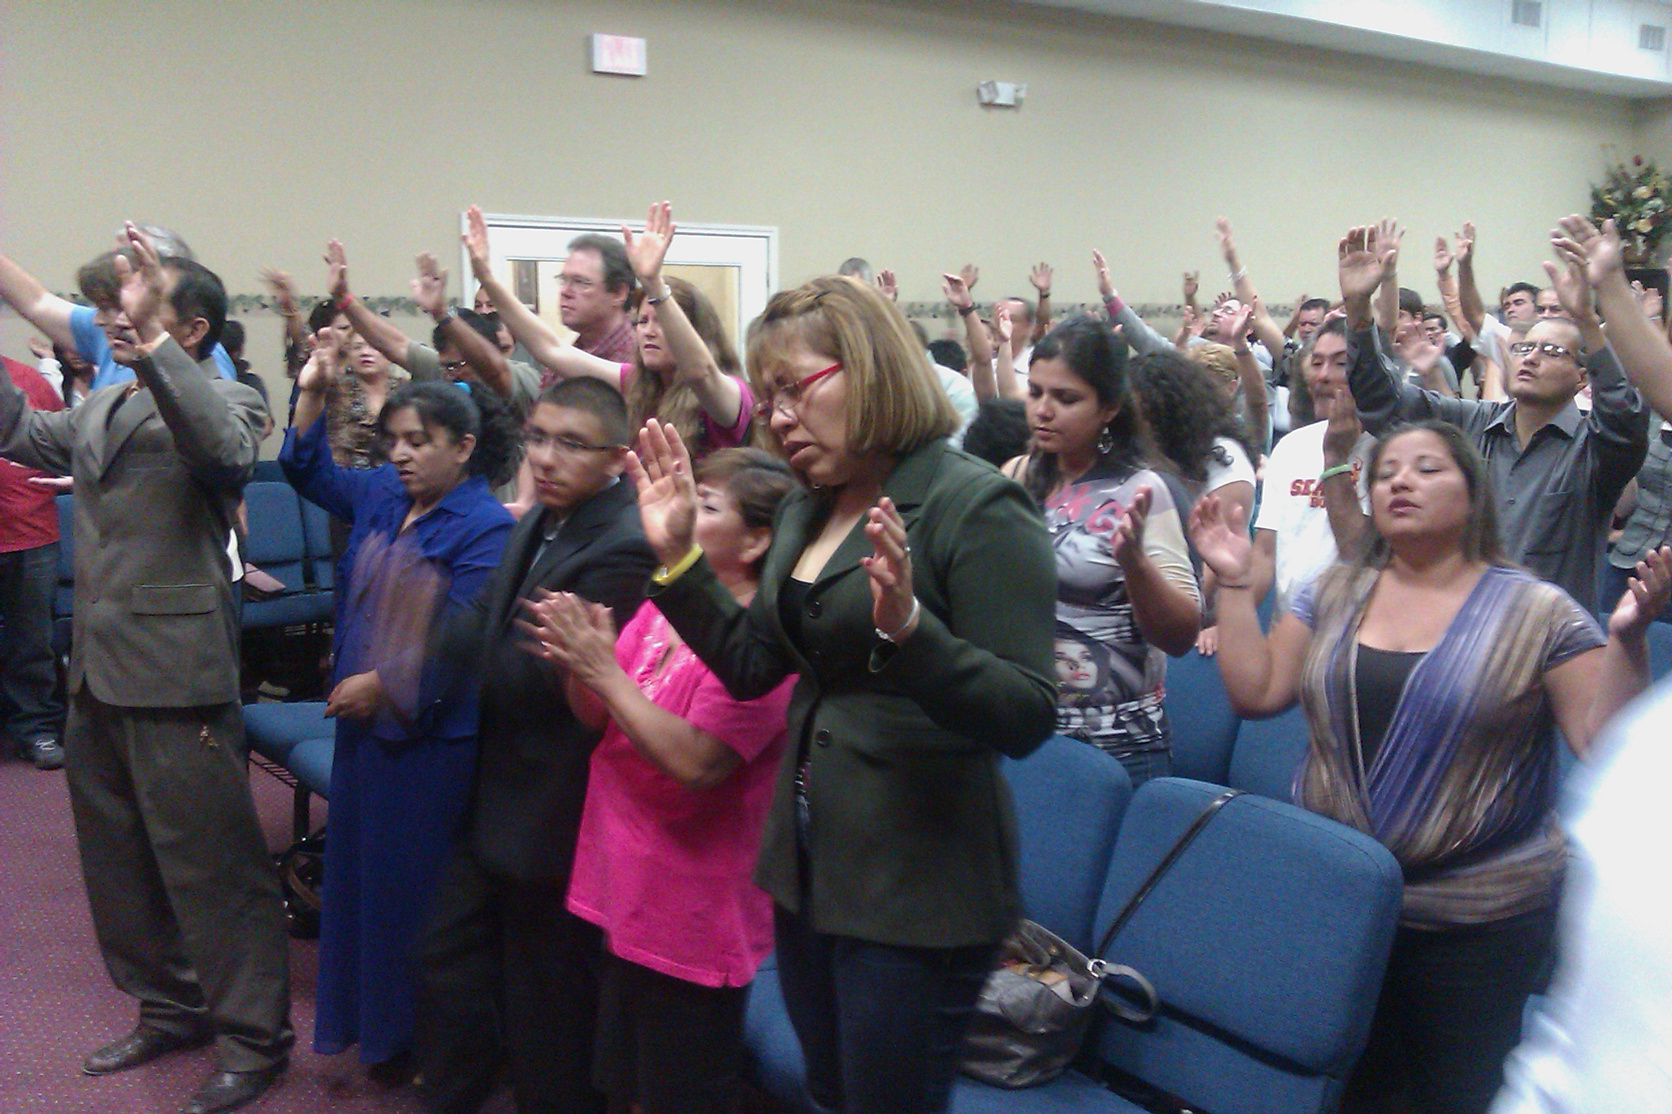
In September I spoke at a regional transformation conference in Laredo, Texas. I was joined by several of the young adults from our Summer Transformation Intensive, which was great! The weekend was powerful! The Lord came with His presence and revelation of transformation exploded in the hearts of hundreds of leaders! In addition to leaders from Laredo, the event drew leadership delegations from 5 cities in Mexico who are desperate for transformation!

Each community has since gone back and gathered other leaders in their city and begun to prepare for the consecration process! Several cities have already gone through consecration with incredible testimony, miracles and breakthrough in families and congregations!
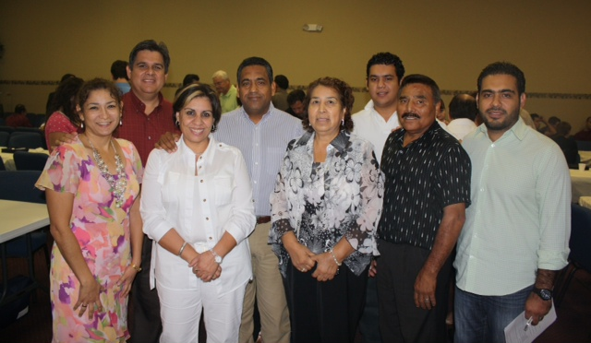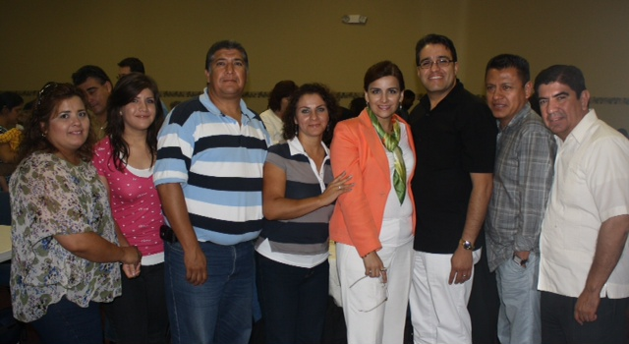

Monterey Leadership Delegation
Acuna Leadership Delegation

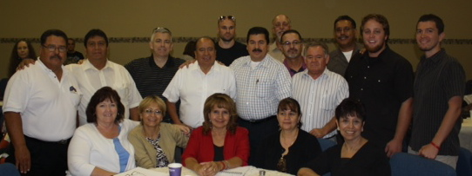
Juarez Leadership Delegation

Consecration in Laredo Texas!
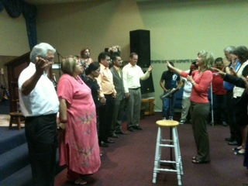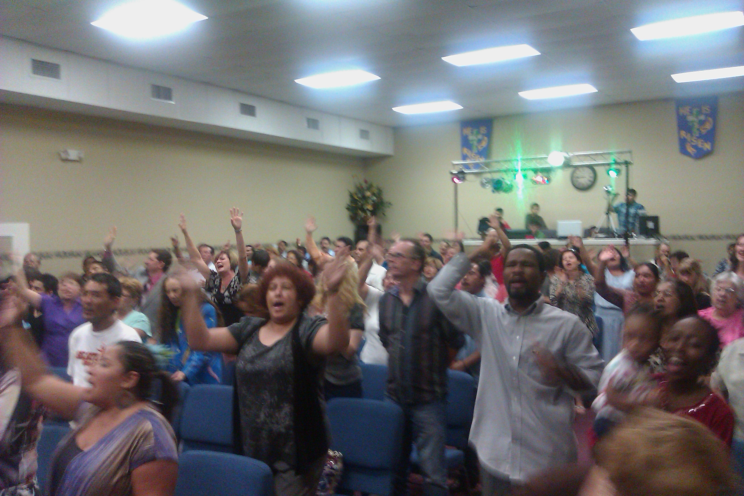
“Face to Face” Consecration in Laredo, Texas

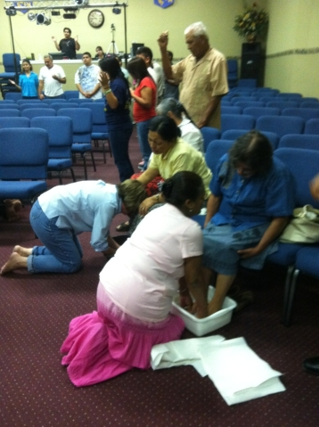
Sunday night following the conference in Laredo, we launched a consecration process with 6 congregations and about 200 people! They had an explosive 21 days! The Lord broke in with His presence from the first prayer meeting! The first Saturday night the pastors decided to wash the feet of the members of their congregations. The meeting lasted for over 3 hours and as they washed each others’ feet they heard the thunder outside…the heavens opened over Laredo that night and it poured rain! In the midst of unprecedented drought in Texas, the Lord opened the heavens over Laredo. It rained several times during the 21 days…a miracle in the midst of the worst drought in Texas history! There was great rejoicing in the city as the Lord drew near!

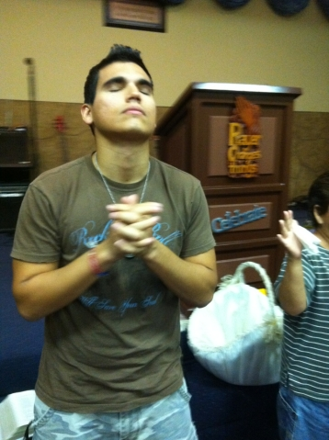
120 believers of every age and church backgrounds met and prayed every day for 21-days, seeking the Lord and humbling themselves! The scheduled 1 hour prayer meetings continued for 3-4 hours as people wept in repentance and brokenness before the Lord and each other!

Every participating pastors marriage was healed and dramatically changed! They are experiencing restored joy and renewed love!
Families were restored. Children were reconciled to parents and to one another! A father who had walked away from his family and God for 40 years returned and he is coming back to the Lord!

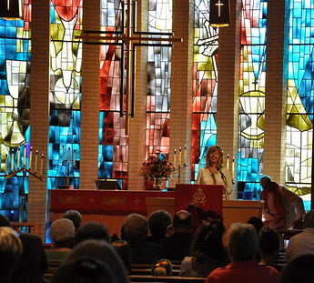
First Lutheran Church
Corpus Christi, TX
In October I had the joy of speaking at a Lutheran church pastored by dear friends outside Corpus Christi. This couple participated in the first Divine Experiment in Council Bluffs in 2007 and are still being impacted by it! To listen to message: “Presumption or Desperation” click here:

http://vimeo.com/channels/firstogtx#31355657
“The Net” – Corpus Christi, TX
The Friday night I arrived in Corpus Christi I spoke to a young adult ministry called “The Net”. The night was incredible! They were so hungry for the presence of God! When I called them forward for ministry the power of God just fell on them! They were laying all over the floor, under tables, it was intense, some were laughing, many weeping. Then they started repenting spontaneously!! God really touched their hearts for intimacy with Him. Campus ministry leaders from the University want to go through the “Face to Face” process next spring!

Transformation Ministry in Communities

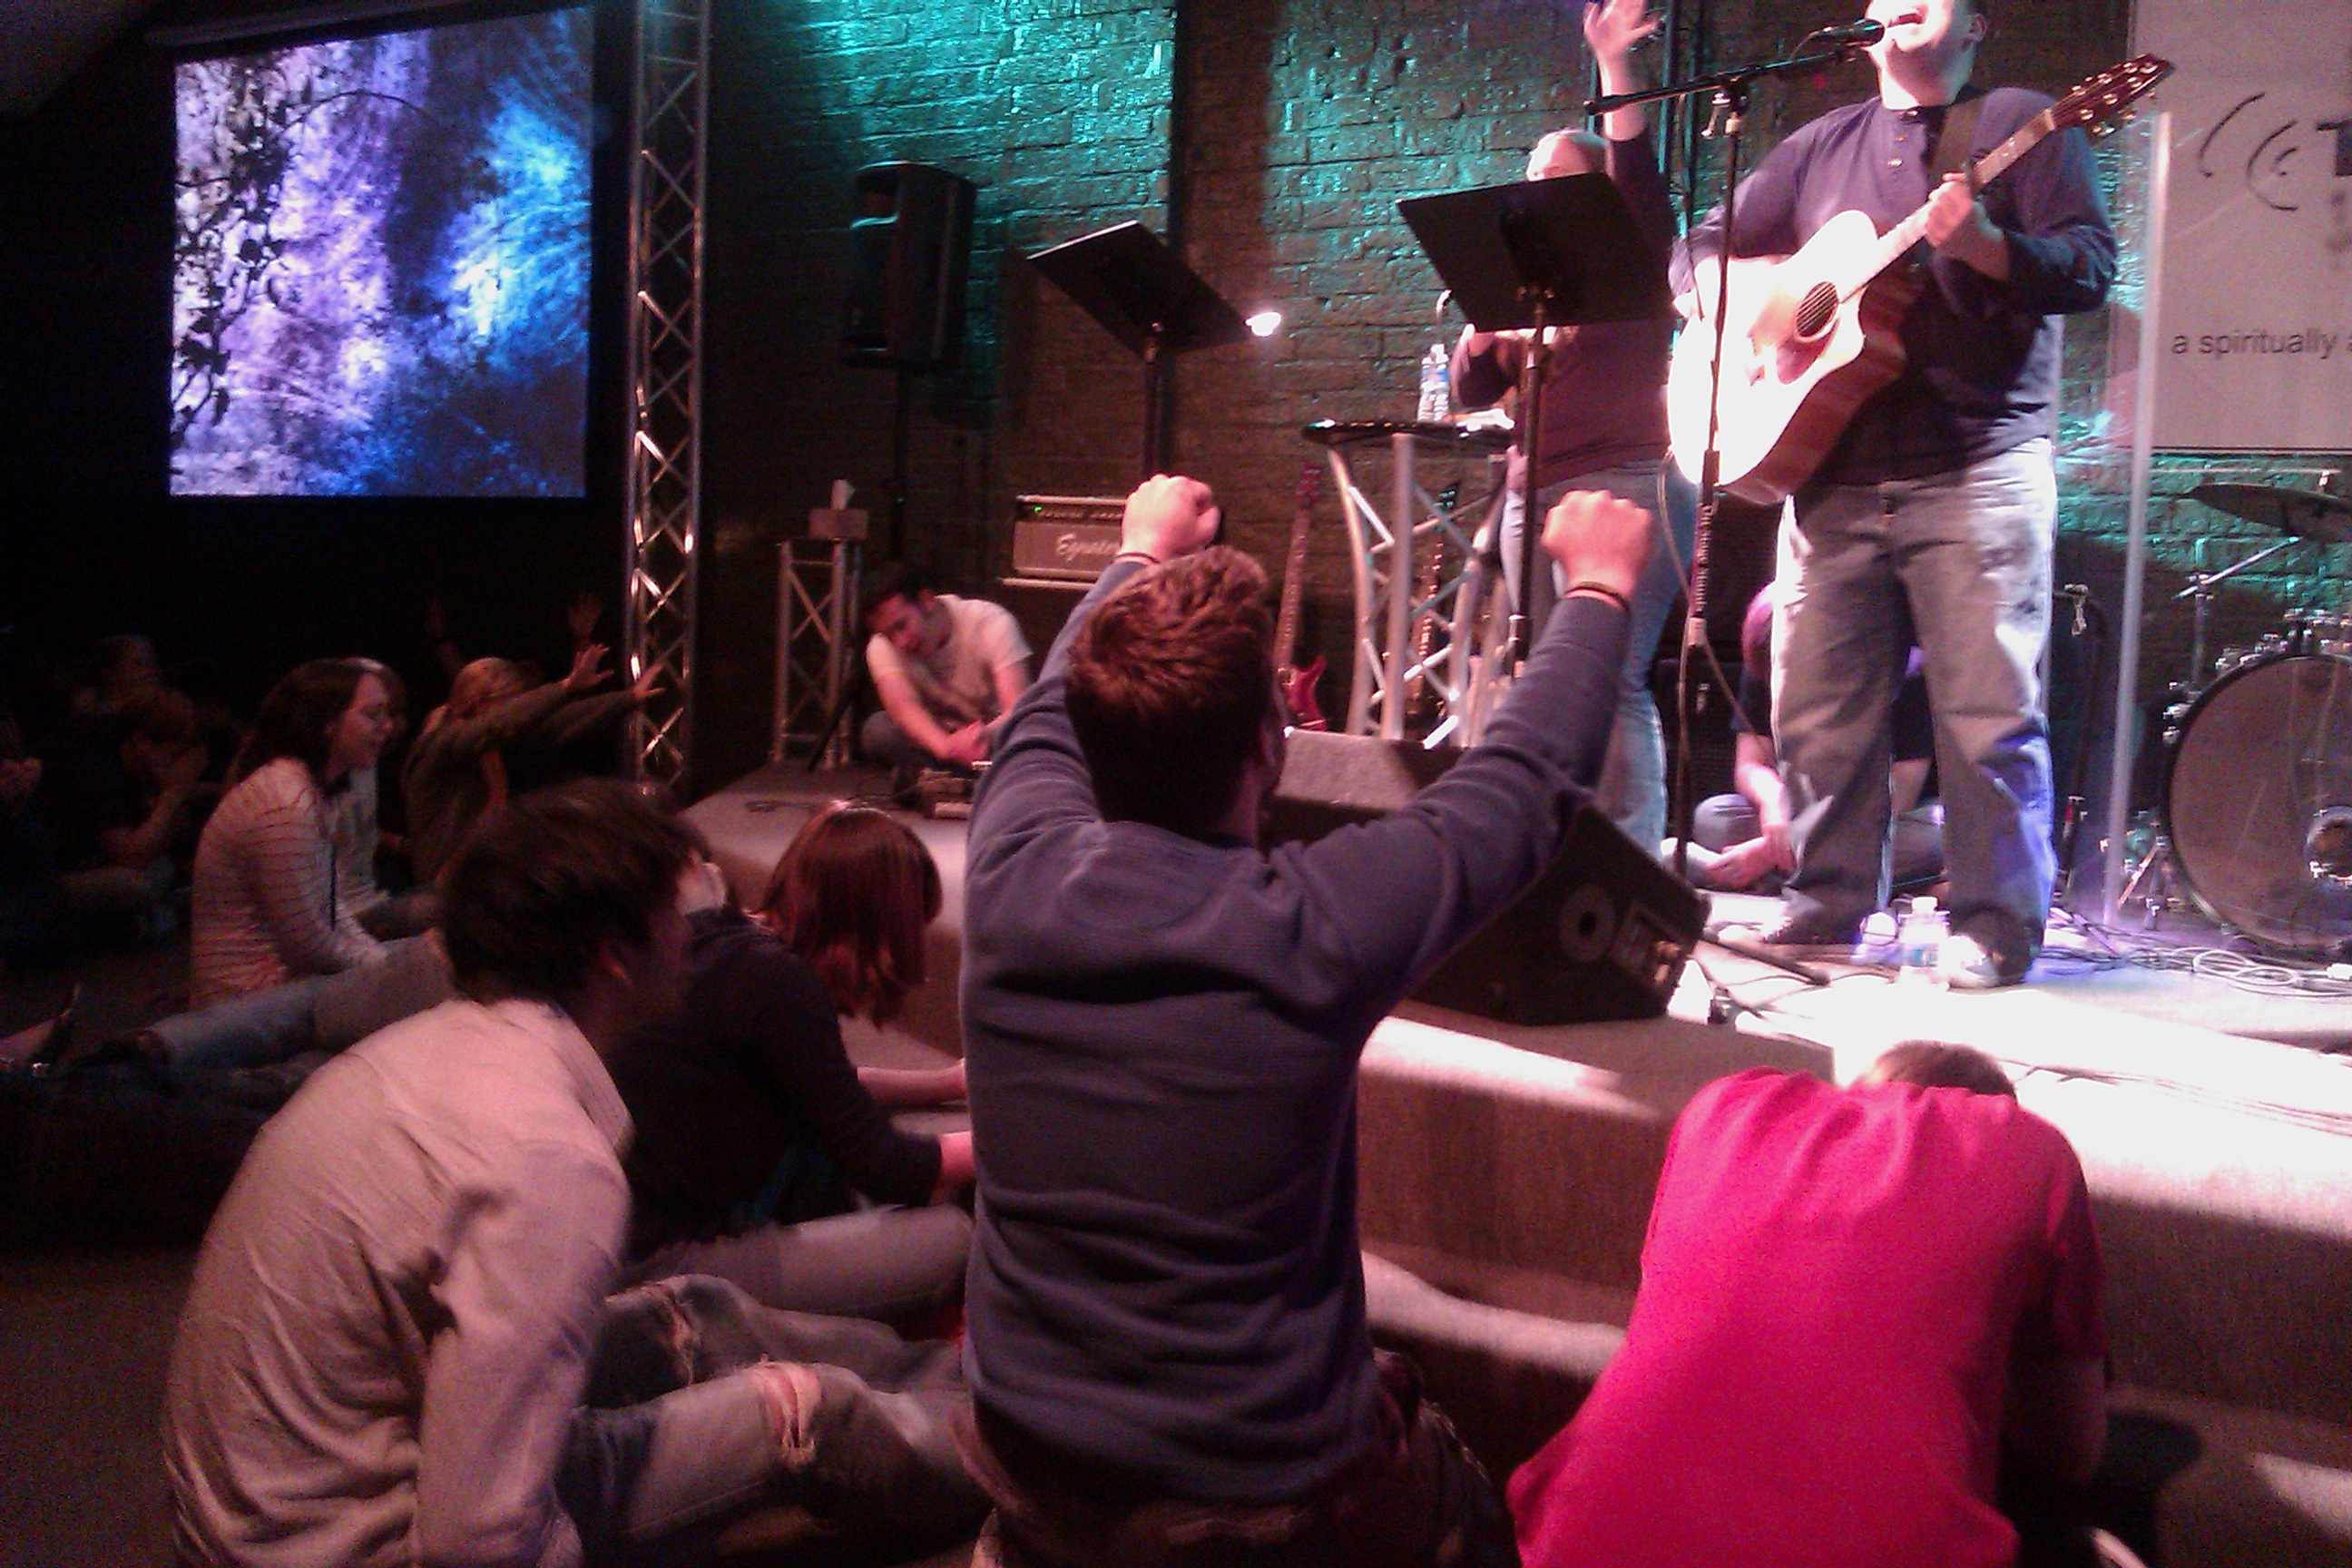

“Face to Face” Consecration - Pinehurst/Tomball, Texas

In November, 7 congregations participated in the consecration process in a suburb of Houston. I had the joy of being at their launch – it was charged with expectation! The Lord came with His presence and transforming power. It was life-changing for them and they now transitioning into a lifestyle of consecration and devotion to prepare for community transformation!

For testimonies click here: http://www.thedivineexperiment.com/Pinehurst-texas.php
Communities Preparing for Consecration in 2012
Cleveland, Ohio
I had a wonderful time speaking at a regional transformation event in Cleveland! They were hungry and ready to consecrate themselves to the Lord and begin the transformation process. We had powerful days together and I’m excited about what the Lord is stirring in this city!

Winchester, Virginia
In November I spoke to a wonderful group of pastors from several communities around Winchester. Friday we had a leadership consultation on transformation. That evening I spoke to a citywide gathering and then a seminar on Saturday. I was so encouraged to meet leaders who were prepared for the transformation process. They are making plans to go through the “Face to Face” consecration process early next year!

Washington, Pennsylvania
While I was in Virginia, 6 leaders from Washington drove 6 hours in one day to meet with me about the consecration process and transformation of their community! These leaders have also been prepared by the Lord and praying together for 15 years for their city. They are also making plans to go through the “Face to Face” consecration process early next year!

Oklahoma City, Oklahoma
I recently returned from a trip to Oklahoma City where I met with pastors and leaders of the city. In addition to a leadership consultation, I met with student ministry leaders of 2 universities who are excited about doing the “Face to Face” consecration on their campuses next spring!

Get Involved!

Would you prayerfully consider becoming a ministry partner with Fusion? We need friends to partner with us in prayer and financial support for the season ahead for bringing the message and lifestyle of consecration to the next generation, to Mexico and communities in the United States.

To support our ministry click on “Support” http://www.fusionministry.com/needs.php

or send a check payable to: “Fusion Ministries” and mail to:

Fusion Ministries, Inc., 721 Main Street, Suite 105, Grandview, MO 64030
Website: www.Fusionministry.com
All Contributions Are Tax Deductable

