Fall Ministry Report 2012

Washington D.C. – Face to Face with Jesus!
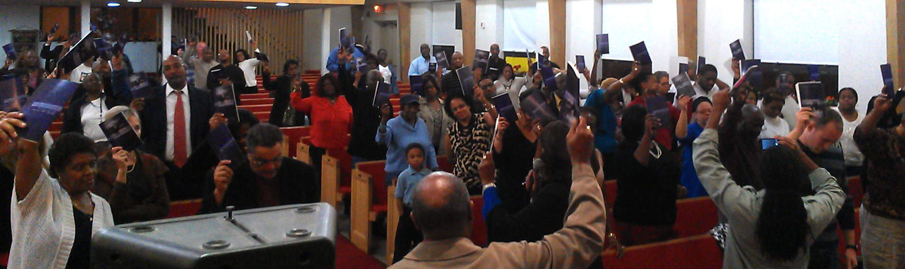

Almost 400 people and their families from 7 congregations/ministries participated in the first “Face to Face” consecration process in the heart of Washington D.C. in the weeks leading up to the election. They were hungry for God and desperate for a return of His presence to the church! The Lord moved powerfully as people humbled themselves and prayed, repented for their sins and cried out to the Lord together. A couple testimonies:

- An 8-yr old boy came forward and prayed “Jesus forgive me for watching movies that give me nightmares please take away my nightmares”. On the final night he brought a plastic bag to the altar filled with movies that had given him nightmares and said “I’m giving them to Jesus”.
- A man who had just been released from prison after 8 years walked past the church the first week of the prayer meetings. A couple coming to service invited him to come in. He came in, walked down the aisle, faced the cross and began to talk to Jesus saying “I’m not a Christian and I don’t know how to pray but I need Your help. I want you to help me.” He gave his heart to the Lord that night.
- One night, two ladies, both blind took the Metro to come to the prayer meeting. They met a woman on their way and convinced her to join them! She came to the meeting and gave her heart back to Jesus! She stood in front of the cross and said "Lord, I've heard about the 'blind leading the blind' but here I am! She rededicated her heart to the Lord!

In July I traveled to Washington D.C. to meet with Harold Brinkley, a key leader in the city. Harold leads a ministry “Project Bridges” and is turning his focus to presence-based transformation. This fall I had the privilege of leading a leadership seminar for him with key leaders in church, marketplace and government in conjunction with Regent University.
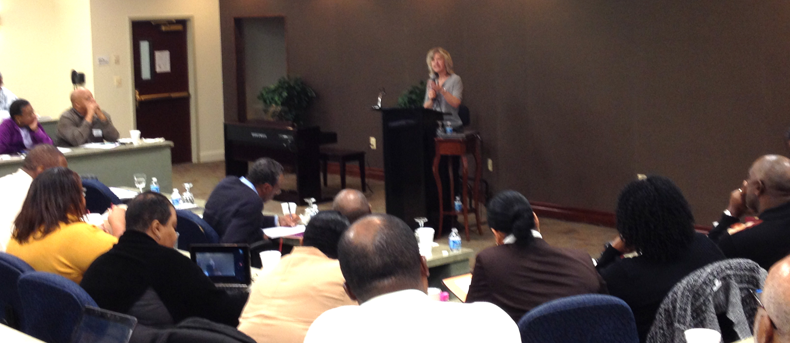
The response to the message was overwhelming, it was a powerful day! God is moving in Washington D.C.!

Regent University Seminar

“Face to Face” Consecration
Texas A & M
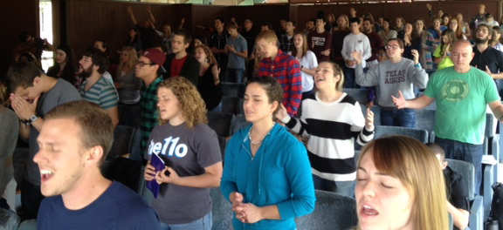
This was the 3rd time Texas A & M has gone through the “Face to Face” process. Lead by a team of 12 student-leaders from 6 different campus ministries, the Lord took them deeper in His presence than every before! The Spirit washed the students in His presence, as they came forward to the microphone confessing deep childhood wounds. The prayer meeting quickly became a corporate ministry time! The Holy Spirit poured out powerful conviction of pride and spiritual arrogance. It was a not uncommon to see leaders openly weeping over and repenting for their pride on the microphone! A spirit of holiness made a mark on every heart that participated, many people had testimonies of having “Face to Face” encounters with Jesus and felt the love of the Father!

“Face to Face” Consecration – Brownsville, TX
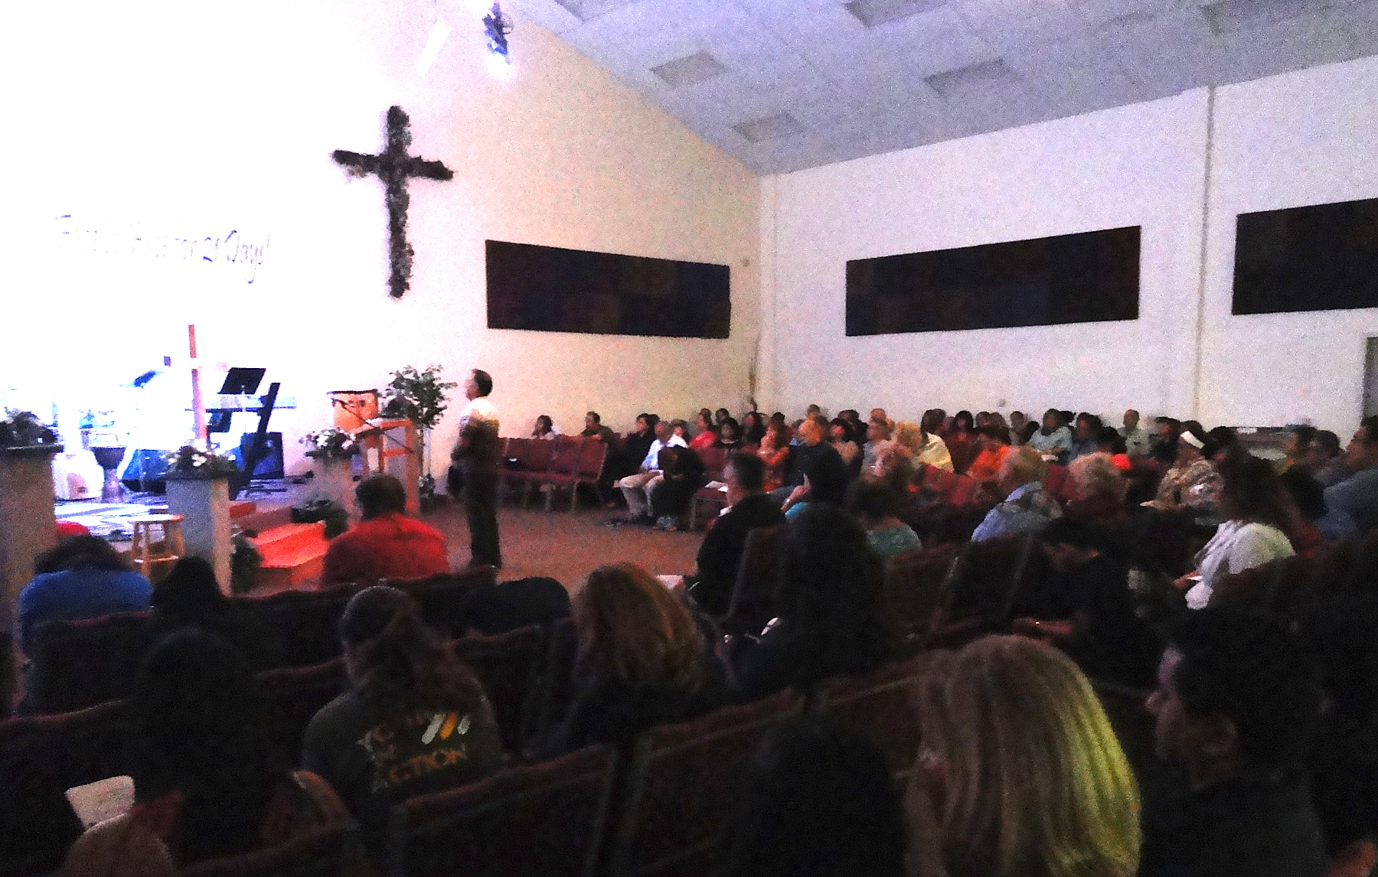
Hundreds of people from 8 ministries participated in their first consecration process, including 85 students from a Christian high school! Over 100 people gathered and prayed every night, standing in front of the cross, confessing sin and pride and returning to wholehearted devotion to Jesus. The Lord answered in powerful ways! Restored intimacy with Jesus! New jobs! Healing of hearts and bodies and relationships! A couple awesome testimonies from the high school students:

- “We are often quick to ask God for things. We ask Him for important things like for the violence in Mexico to stop. If we are not getting the desired results it can’t be God’s fault, He is not a broken wish-granting factory. Obviously something must be wrong with us. We expect God to be like a magic wand and give us what we want. Before asking we need to look at ourselves and realize that we are proud and selfish people. I have realized during these 21 days a truth that I had sung a million times....Humble yourself in the sight of the Lord and He will lift you up.”

- “Have you ever tried sacrificing something you really like? It is very hard. I really like coffee and cookies and for the last 21 days, I sacrificed it. Although it is difficult, the love of God strengthened me. I thought I had to drink coffee with cookies every morning in order to be in a good mood, but I proved myself wrong. I did eat a cookie, but it was an accident...”

“Face to Face” Consecration – Mission, TX

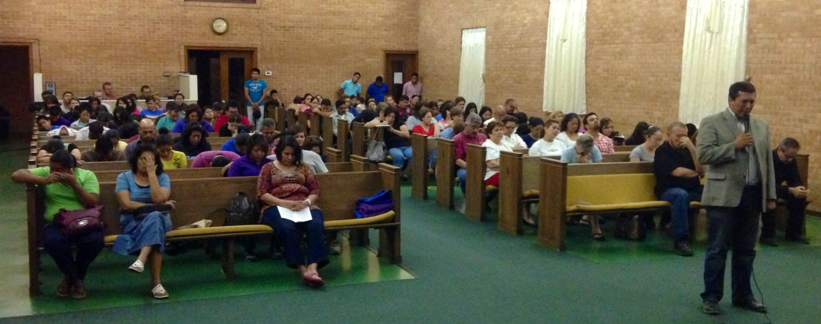
Hundreds of people from Spanish congregations along the border cried out to the Lord and He answered with many testimonies! Over 500 people attended the Celebration Service!

Juarez House of Prayer Established!
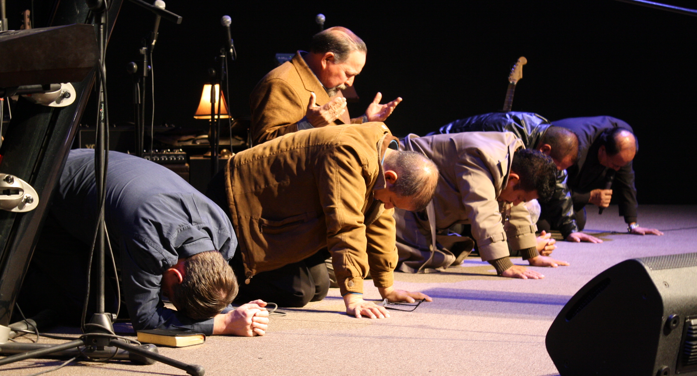
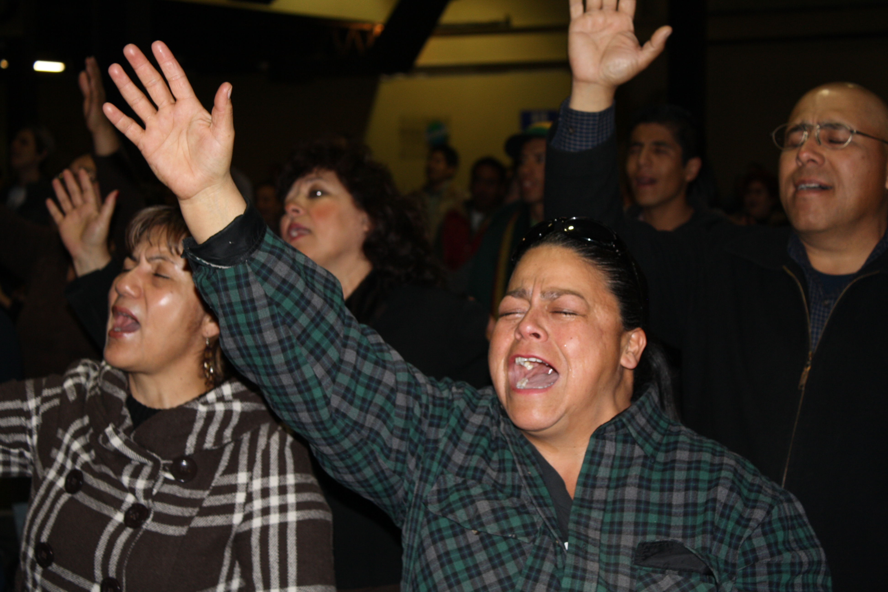
In the past year thousands of believers in Juarez have participated in our “Face to Face” consecration with dramatic and miraculous response from heaven. Jesus has unified a praying people and established a spiritual family out of the fear and desperation, bringing a vision of hope and transformation to the city and it’s people.

The result? Within 3 months the atmosphere of the city began to change, cartel activity slowed and crime rates dropped. Within 6 months the murder rate plummeted by 59.8%! The crime rate by 75%! The economy is rebounding, and life has returned to the city – all reported by secular media sources including the Washington Post, Forbes, CNN, etc.

Pastors and leaders in Juarez are now intentionally pursuing presence-based transformation and partnering with us to see God’s glory manifest in the city!
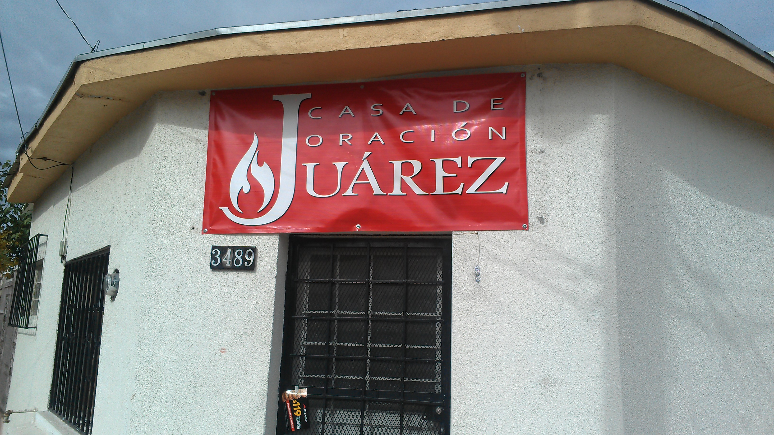
In July, we established a house of prayer and transformation center and the Lord has been so faithful to breathe on it and give so much favor, presence and blessing!

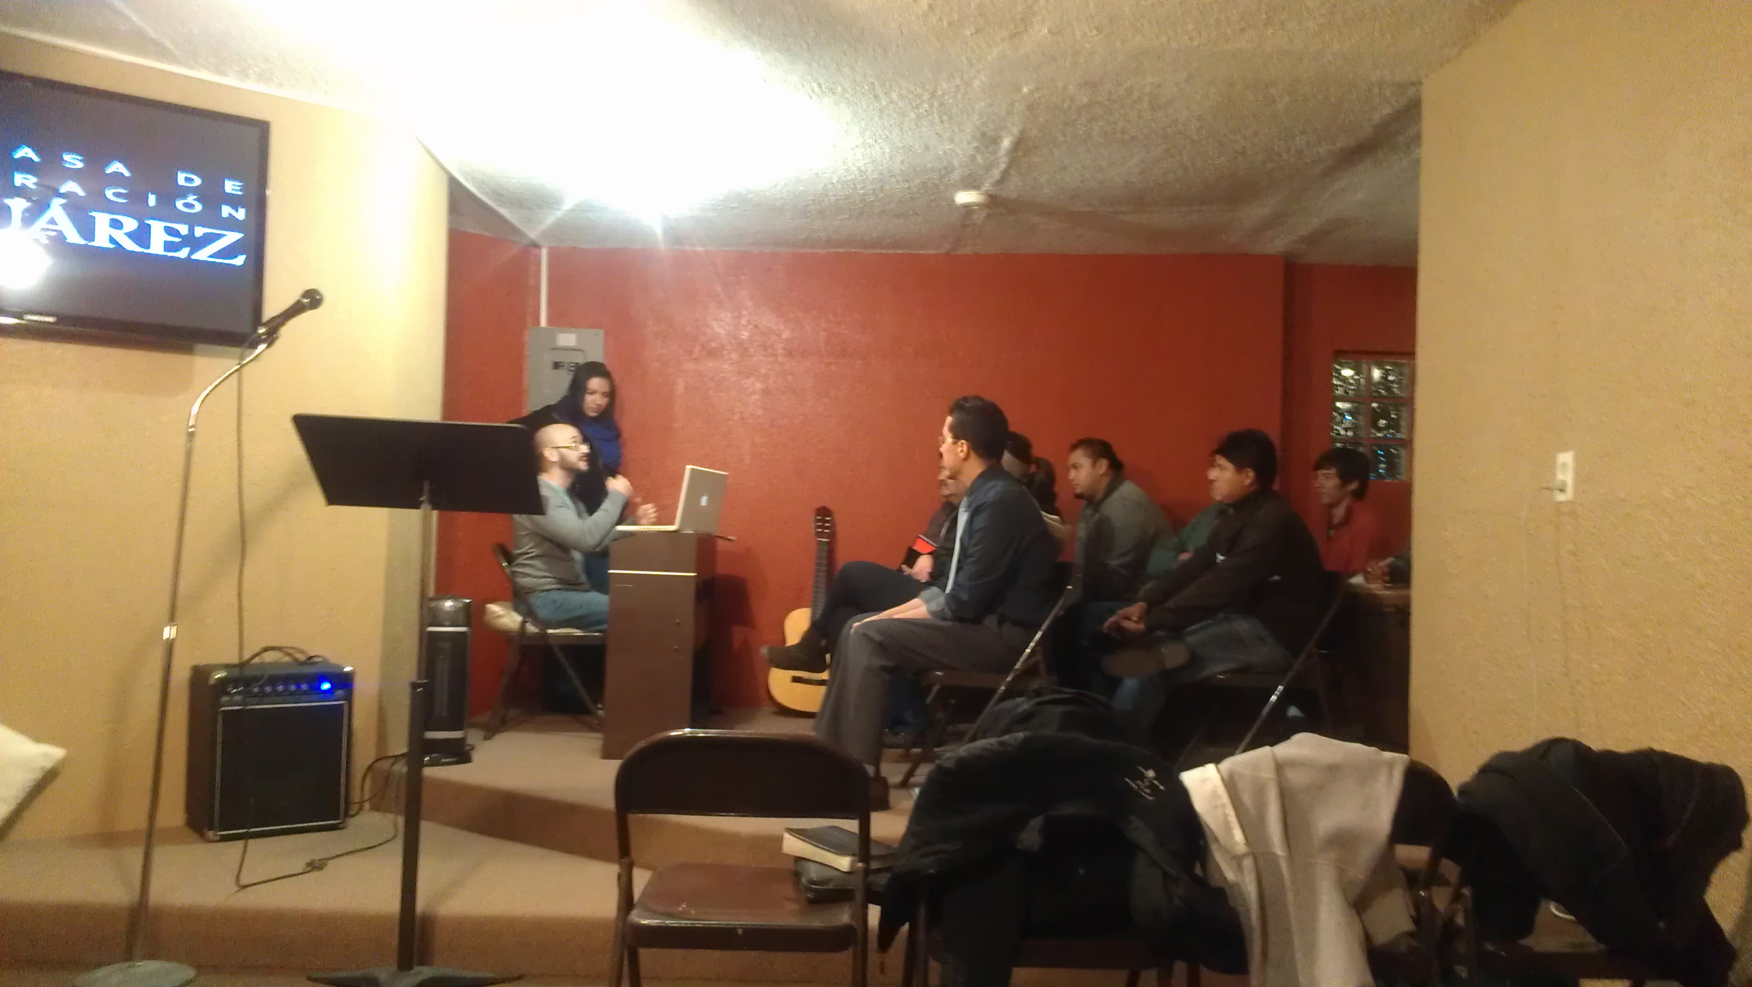
In God's great love and mercy He is inviting very weary people to ascend the mountain of the Lord Isa. 56:7 (the place of presence and glory) to encounter Him and He will make them JOYFUL!!! In His house of prayer! The house of the Lord in prayer and worship has been established in the former "murder capital of the world" that is REDEMPTION!

After 4 years of cartel wars and 11,000 people being murdered, 150,000 people fleeing the city and thousands of businesses closing...here are a couple headlines of the transformation God has been doing in Juarez:

- March 22, 2012 “Is Ciudad Juarez Turning Around?” – Salem News
- May 28, 2012 “Life stirs anew in ‘murder capital’ Juarez – Washington Times
- July 14, 2012 “Juarez slayings decreased 59.8% first half 2012” – El Paso Times
- August 20, 2012 “In Mexico’s murder city, the war appears over” – Wash. Post
- August 27, 2012 “Why Is Mexico’s Murder City Attracting Investors” – Forbes

Only God can do this, it's stunning - a transformation more powerful and occurring more quickly than any transformation story I have ever heard about anywhere in the world. We have the privilege of being a part of it through our prayer, sowing and serving. Thank you for being a part of our team and partnering with Jesus as He pours out His love and mercy in this city!

Fusion Family News
Fusion Ministries has a new home! We moved into a lovely house with more office and meeting space. Our rent is actually less each month praise the Lord!

Fusion Family - Left: Brook, Makela Otis (w/baby Sawyer) Rhonda Hughey, Adam Sebastian & Becky Gomez (Juarez, Mexico). Back left: Kara VanHover Marie Grotte, Pastor Roberto Avendano (Juarez, Mexico)

Get Involved!
Thank you for being a part of real transformation!. We appreciate you and depend on your generosity to continue to serve the Lord as a catalyst for revival in the church.

Would you prayerfully consider becoming a ministry partner with Fusion? In addition to monthly support, we need $4,000 before the end of the year to help with a couple very strategic projects: 1. publishing “Desperate for His Presence” in Spanish ($2,600 cost), 2. redesigning and launching our new website ($1,000), 3. improving our database and communication management systems. All of this will greatly improve the communication of the ministry and make the message of “Desperate for His Presence” available in Mexico and Latin America!

To support our ministry click here: http://www.fusionministry.com/onlinegiving.php

or send a check payable to: “Fusion Ministries” and mail to:

NEW ADDRESS!
Fusion Ministries, Inc.
11222 Norton Avenue, Kansas City, MO 64137

All Contributions Are Tax Deductable

