Fusion Ministries Update

Texas A & M University

Celebrating God’s Goodness!

The “Face to Face” consecration at Texas A & M was a powerful time! Hundreds of people gathered Sunday night March 6th for the Celebration service where for 3 hours testimonies were shared about all the Lord had done among His people as they humbled themselves, prayed together seeking His face and repented for their sins. The Lord came and responded to them in sweet and wonderful ways.

An older man joined us at the launch of the Divine Experiment and shared that he has been praying in the chapel on campus for 25 years for revival!! He participated during the prayer meetings and said he has never seen anything like this before on campus! Praise the Lord!

Marriages and families were healed! Many people had supernatural encounters with the Lord and found new intimacy with Him! Students became bold in their faith and are ministering to many on the campus! One girl was talking to 10 Chinese students and 7 of them gave their hearts to the Jesus! People were saved, healed and delivered!

Three congregations participated in the Divine Experiment and had tremendous testimonies! One man who was on life-support and given no hope to live was touched by the Lord after prayer and returned home to his family! A worship leader who was hospitalized for viral meningitis was healed and new test results showed no virus and he was released!

Adam Moser, spent a couple of days with the student leaders stirring their faith and exhorting them to believe God for the fullness of what the Lord wants to do on their campus. He helped them see the bigger picture and called them to press in for God’s fullness of transformation!

For amazing testimonies visit: www.thedivineexperiment.com! (MAKE A LINK)

Transformation Leadership Retreat
Seattle – March 7th – 12th

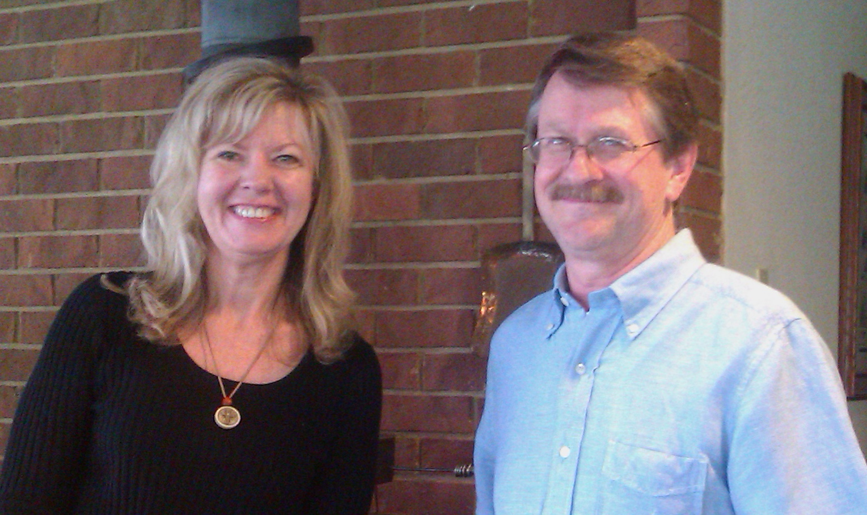
I joined 10 other ministry leaders to spend a week together with George Otis, Jr. to pray, fellowship and seek the Lord about transformation in North America. We had an amazing time! The fellowship was great, we laughed, shared and prayed together in addition to meeting for almost 12 hours every day. It was intense but awesome!

Rhonda & George Otis, Jr.

The Lord was really with us, it was a strategic time to seek the Lord as to how our ministries could increase our focus and resources on transformation in our nation. By the end of the week a new fellowship was formed. We are now on our way to releasing a new “voice” for presence-based transformation activity in the United States! You’ll hear more in the coming months.
One of the highlights for my time at the retreat was spending time with Doug and Linda Abner from Manchester, Kentucky, the first transformed community in the USA. They are incredible people and have so much to share about what the Lord has done! Their story is one of humility, desperation, prayer and divine intervention! For more information get the DVD on our website “An Appalachian Dawn”.

Doug & Linda Abner from Manchester, Kentucky

To view a trailer of the documentary click here:
http://www.glowtorch.org/Home/AADwbanner/tabid/2731/Default.aspx

Upcoming Ministry Events

National Leadership Consultation City Transformation
Orlando – April 4th – 6th

The Lord has opened another door to the Lausanne Congress and Mission America Coalition conference in Orlando. I have now been invited to speak at the leadership consultation on transformation, which was quite a surprise. This is a privilege to share the presence-based perspective on transformation to hundreds of leaders in our nation. I will also have the opportunity to introduce the leaders to the Manchester, Kentucky testimony as a powerful example of the extent God is willing bring glorious redemption to people and communities!

The leaders are also opening several doors at the conference to promote our new book REVIVAL. I will have many opportunities to interact with leaders at the event about our books and the message of our ministry. This is an open door to stir faith for presence-based transformation and ignite fire for revival! I will have a unique opportunity to influence leaders of national networks in our nation. Pray for divine appointments, favor and wisdom!

Transforming Revival Seminar &
Divine Experiment Launch Texas A & M University
April 15th – 16th

Another campus ministry wants to go through the “Face to Face” consecration process! The leaders are desperate to refocus their ministry on the Lord and to seek His face. They have been provoked to jealousy hearing the testimonies of how the Lord responded to the other students who consecrated themselves to the Lord. In a couple of weeks, hundreds of additional students will begin a consecration process, humbling themselves, seeking His face and turning from their sin and back to the Lord! Praise God for the contagious nature of His presence breaking in on lives abandoned to Him!

The weekend we launch this second Divine Experiment, I will be speaking at a seminar for the congregations in the city who went through the Divine Experiment. The seminar will help them transition from the 21 days to a lifestyle conducive for the presence of God unto transforming revival. The congregations and students are continuing to meet together, fellowship and pray together regularly and the Lord continues to do mighty things in their midst. They have become a spiritual family and are becoming a dwelling place of the Lord in the Spirit (Eph. 2:22), which is an important first step in preparing for revival!

Revival & Spiritual Revolution Seminar
Texas A & M University
April 29th – 31st

Adam Moser and myself will be speaking at a “Revival & Spiritual Revolution” seminar at Texas A & M for students. The focus of the weekend will be to help students transition from the Divine Experiment of 21 days to living a fasted lifestyle and wholeheartedness to the Lord. We will share about becoming spiritual “revolutionaries” in our generation; the oppression of spirit of the age; the power of Christ in us to bring the hope of glory to friends and families; and change the atmosphere of the campus itself!

We will also be meeting with campus ministry leaders to begin preparation for the consecration process to launch next fall. We are expecting the “stake” in the ground this spring to result in a much broader involvement of ministries on Texas A & M campus next fall!

Prayer Requests

Thank you for your prayer and financial support, if we ever needed you to sow into the ministry it’s now! We have some awesome doors opening to the message of consecration and transforming revival but we are still under-funded by $3,000 each month, which puts tremendous pressure on the ministry. Would you prayerfully consider becoming a ministry partner with Fusion and sowing into the Kingdom activity the Lord has set before us? Contributions are tax-deductible and can be sent to:

Fusion Ministries, Inc.
721 Main Street, Suite 105, Grandview, MO 64030

Website: www.Fusionministry.com
Blog: Fusion4revolution.blogspot.com (put link)

Fusion Ministries, Inc. is now on Facebook! (put link)

