Fusion Ministries Update
May 2011

Greetings and peace to you in the powerful name of Jesus!

We have had an amazing couple of months. The Lord continues to breathe on our ministry at Texas A & M – the root system is deepening in the hearts of the students, the fruit of the consecration is abundant and the fire is beginning to spread to other campuses in Texas and beyond. These are exciting but challenging days. It’s a new direction for us as a ministry but a refreshing one!

Campus revivals have always been used by the Lord in revival history to become centers of contagious spiritual life and “fire” for communities around them. I believe the Lord is igniting fresh faith in this generation to stir the church in our nation out of complacency and compromise. Please join us in praying for this new ministry focus!

Rhonda Hughey
Director, Fusion Ministries

National Leadership Consultation
Orlando, FL

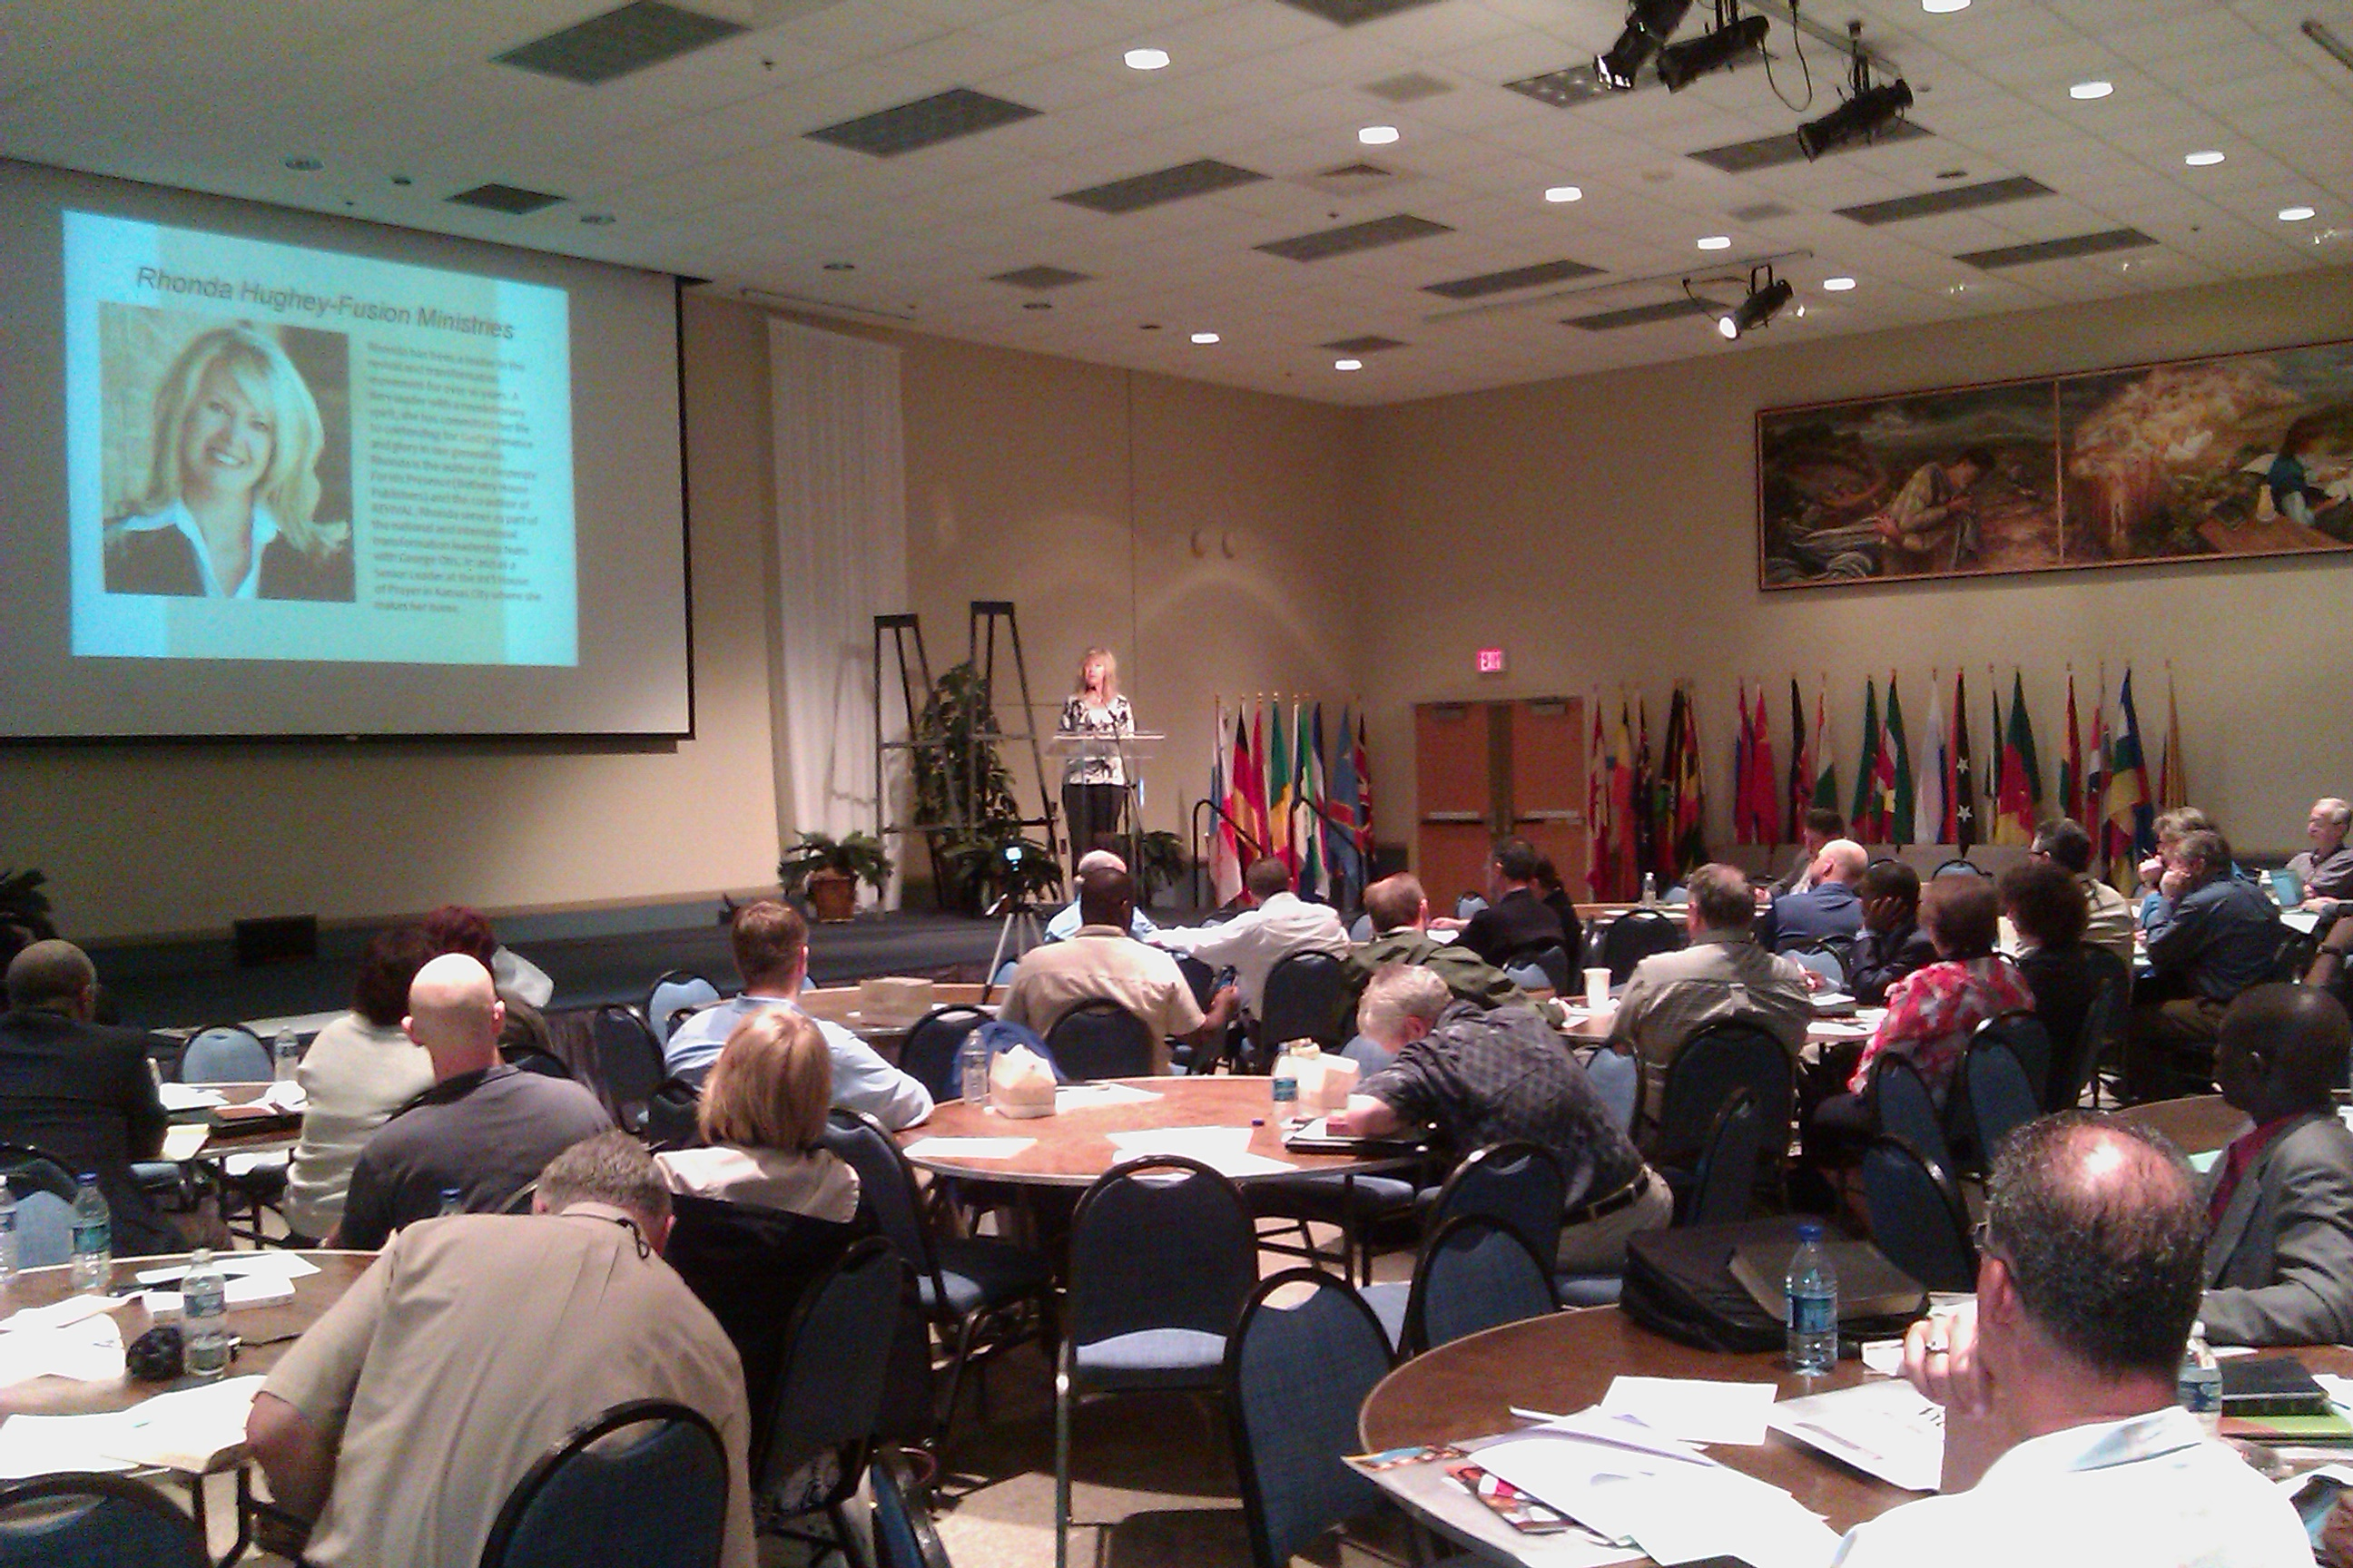
In April, I had the privilege of addressing 60 leaders of city reaching networks from around the United States.
I presented an overview of what transforming revival and supernatural transformation are, the role of the manifest presence of God in transformation and the process He requires to transform the church and a community. It was a clear definition and challenge to the man-centered approach that has become so common in our nation.

I also presented the first documented transformation testimony in the United States - Manchester, Kentucky and showed a clip of the newly released documentary "Appalachian Dawn". It was powerful! What a privilege to speak to these leaders and encourage their hearts and stretch their faith to belief God for more than human strategies but for His Kingdom to come where we live!

To watch the 20-minute presentation on presence-based transformation click:

http://www.flipshare.com/api/ViewFbReshare.aspx?i=fd6acc79-86f9-4e41-a13d-f4c5523b2471

During the conference I also had wonderful re-connection with leaders from many cities that I have known over the past 15 years. The Lord gave a number of significant divine appointments, specifically related to our ministry on university campuses.

Texas A & M University
Weekend Ministry Trip – April 28th – 30th

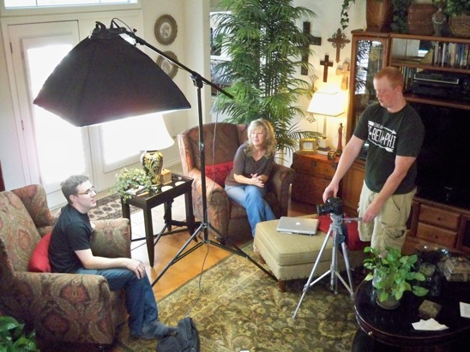
Friday afternoon Adam Moser and I filmed interviews for a promo DVD for the “Face to Face” consecration. Taylor Stanley, a student from A & M (pictured above) is doing the filming, interviews and helping us produce the DVD. The DVD will be used to inspire campus ministry leaders to consider the consecration process next fall based on what the Lord has done, and is doing on the campus of Texas A & M this spring.

“Face to Face” Info Meeting for Campus
Ministry Leaders

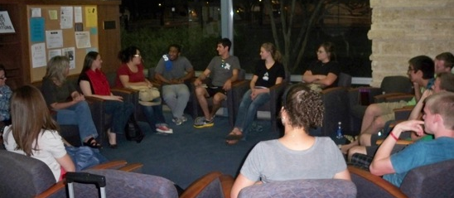

Friday night we held an informational meeting on campus for ministry leaders who were interested in the consecration process next fall. We had a good number of leaders from A & M along with a delegation from the University of Houston who drove down for the evening to join us. We shared the vision, leaders shared their testimonies and we discussed how to increase participation at A & M and in Houston for the fall.

After sharing for a couple hours we prayed to close the meeting about 9 p.m. But when we begin to pray the presence of the Lord broke in and took over the meeting. The Lord began to reveal His heart for the campuses in Texas, prophetic words were released, students encountered the Lord in powerful ways – some for the first time in their lives. For almost 2 hours the Lord ministered to us together in that little room! It was the best “info” meeting I have ever attended! When we finally left about 10:30 we had trouble walking to our cars because we were so affected by the presence of the Lord. The Lord made it clear to us again that He is in this!!!

We are now intentionally trumpeting the call to consecration on 9 other campuses in Texas and Wisconsin as well. In a couple of weeks I will be at the University of Texas – Austin speaking to campus ministry leaders and the regional retreat of InterVarsity leaders from 15 campuses in Texas alone to begin to prepare for the “Face to Face” on those campuses in the fall as well.

Revival & Spiritual Revolution Seminar

Saturday we held a seminar on campus and it was powerful. Adam and I taught on revival, the spirit of the age, the need for spiritual revolution and living a life of radical devotion! During the ministry time the Lord highlighted the idolatry of the university in specific ways and had students renounce the pride, traditions, etc. it was incredible. It was a great day! There is a core of students now on campus that are really walking in understanding of revival and expectant to be participants of it in their generation!

Testimonies!

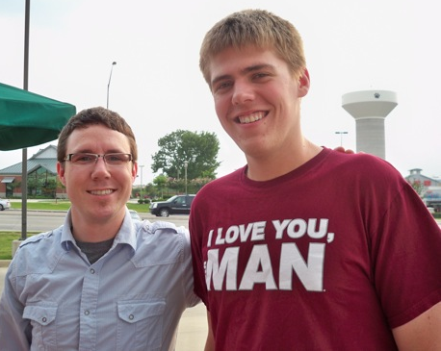
Klark (pictured at left with Adam Moser) is a young man who belongs to a conservative Christian Fraternity on campus. Although they ignored the invitation to join in the consecration process, the Lord had His own agenda for them! During their weekly Monday night meeting in the chapel, the presence of the Lord broke in in power and many of the students got baptized in the Holy Spirit! They started praying for healing and several of them got physically healed! The students encountered the Lord is a new, experiential way and have been changed forever. Since then the Lord is opening their hearts to desiring more of Jesus. These revived students are part of a spiritual revolution out of religious routine and compromised lives and into radical devotion to Jesus!

Friday night as we walked through campus after the information meeting, we ran into a young man who had recently come to Christ. Our friend, Stefan had led him to the Lord over dinner and then through deliverance out of the gay lifestyle! In the middle of the restaurant! He is now reading the PURITY book!!

We heard so many testimonies of increased evangelism on campus as students have become bold in their faith! Atheists are getting saved! Groups of students are praying around campus, reports of healing and students encountering the Lord’s presence and power are increasing!

Please pray for the students as they leave campus for the summer. Pray that the Lord increases their hunger over the summer and that He continues to use them to spread spiritual life and fire wherever they go!

Family News

Many of you have prayed for my mom over the years so I thought I would include a picture here of my parents. They are a huge part of my heart and life and have been walking with me in ministry for many years, praying, supporting, giving counsel and lots and lots of love. My mom is doing well, the Lord has been Faithful to us in contending for her health. Thank you for your prayers for my family! My sister, Renae and her husband Joe and 4-year old nephew Jackson all live here in Kansas City as well. I am so grateful for the blessing of being near family! It’s such a joy and strength to my heart in the midst of my crazy life!

Prayer Team

Please agree with us in prayer for the focus on university campuses this summer to prepare for the consecration “Face to Face” next fall! The Lord has opened so many doors, we need wisdom as we move forward.

Thank you for your prayer and financial support, if we ever needed you to sow into the ministry it’s now! We have some awesome doors opening to the message of consecration and transforming revival but we are still in a serious financial shortfall. Would you prayerfully consider becoming a ministry partner with Fusion and sowing into the Kingdom activity the Lord has set before us? Contributions are tax-deductible and can be sent to:

Fusion Ministries, Inc.
721 Main Street, Suite 105, Grandview, MO 64030

Website: www.Fusionministry.com
Blog: Fusion4revolution.blogspot.com

Fusion Ministries, Inc. is now on Facebook!

