Fusion News - March 2011

Texas A & M University

Consecration unto
Radical Obedience!

A couple of weeks ago, I stood in the chapel one of the largest universities in our nation and invited students and campus ministry leaders to consecrate themselves to the Lord for 21 days. It was a call to separate themselves from the world long enough to change their appetites, to humble themselves before the Lord, seek His face in intimacy and to repent for their sins that have offended His holy presence (2 Chron. 7:14).

It was an invitation from Jesus to seek Him every day for 21 days until He had regained the primary affection of their hearts. Early morning prayer meetings! No T.V.! Fasting food, no shopping, internet, Facebook! Radical stuff. They said yes!

On February 13th I returned to Texas A & M and together with several campus ministry leaders and pastors we launched “Face to Face – The Divine Experiment” with 300 students on the campus to separate themselves from the influence of the spirit of the age radically realign their hearts with Jesus!

Since the launch (see photo below of chapel service) the Lord has been moving in presence and power among the students. They are encountering the Lord in life-changing ways, spiritual, emotional and financial breakthroughs are occurring! They are enjoying being together as God’s family seeking His face every day in the chapel. A leader who has been praying for revival in the chapel for 25 years says he has never seen anything like this on the campus!
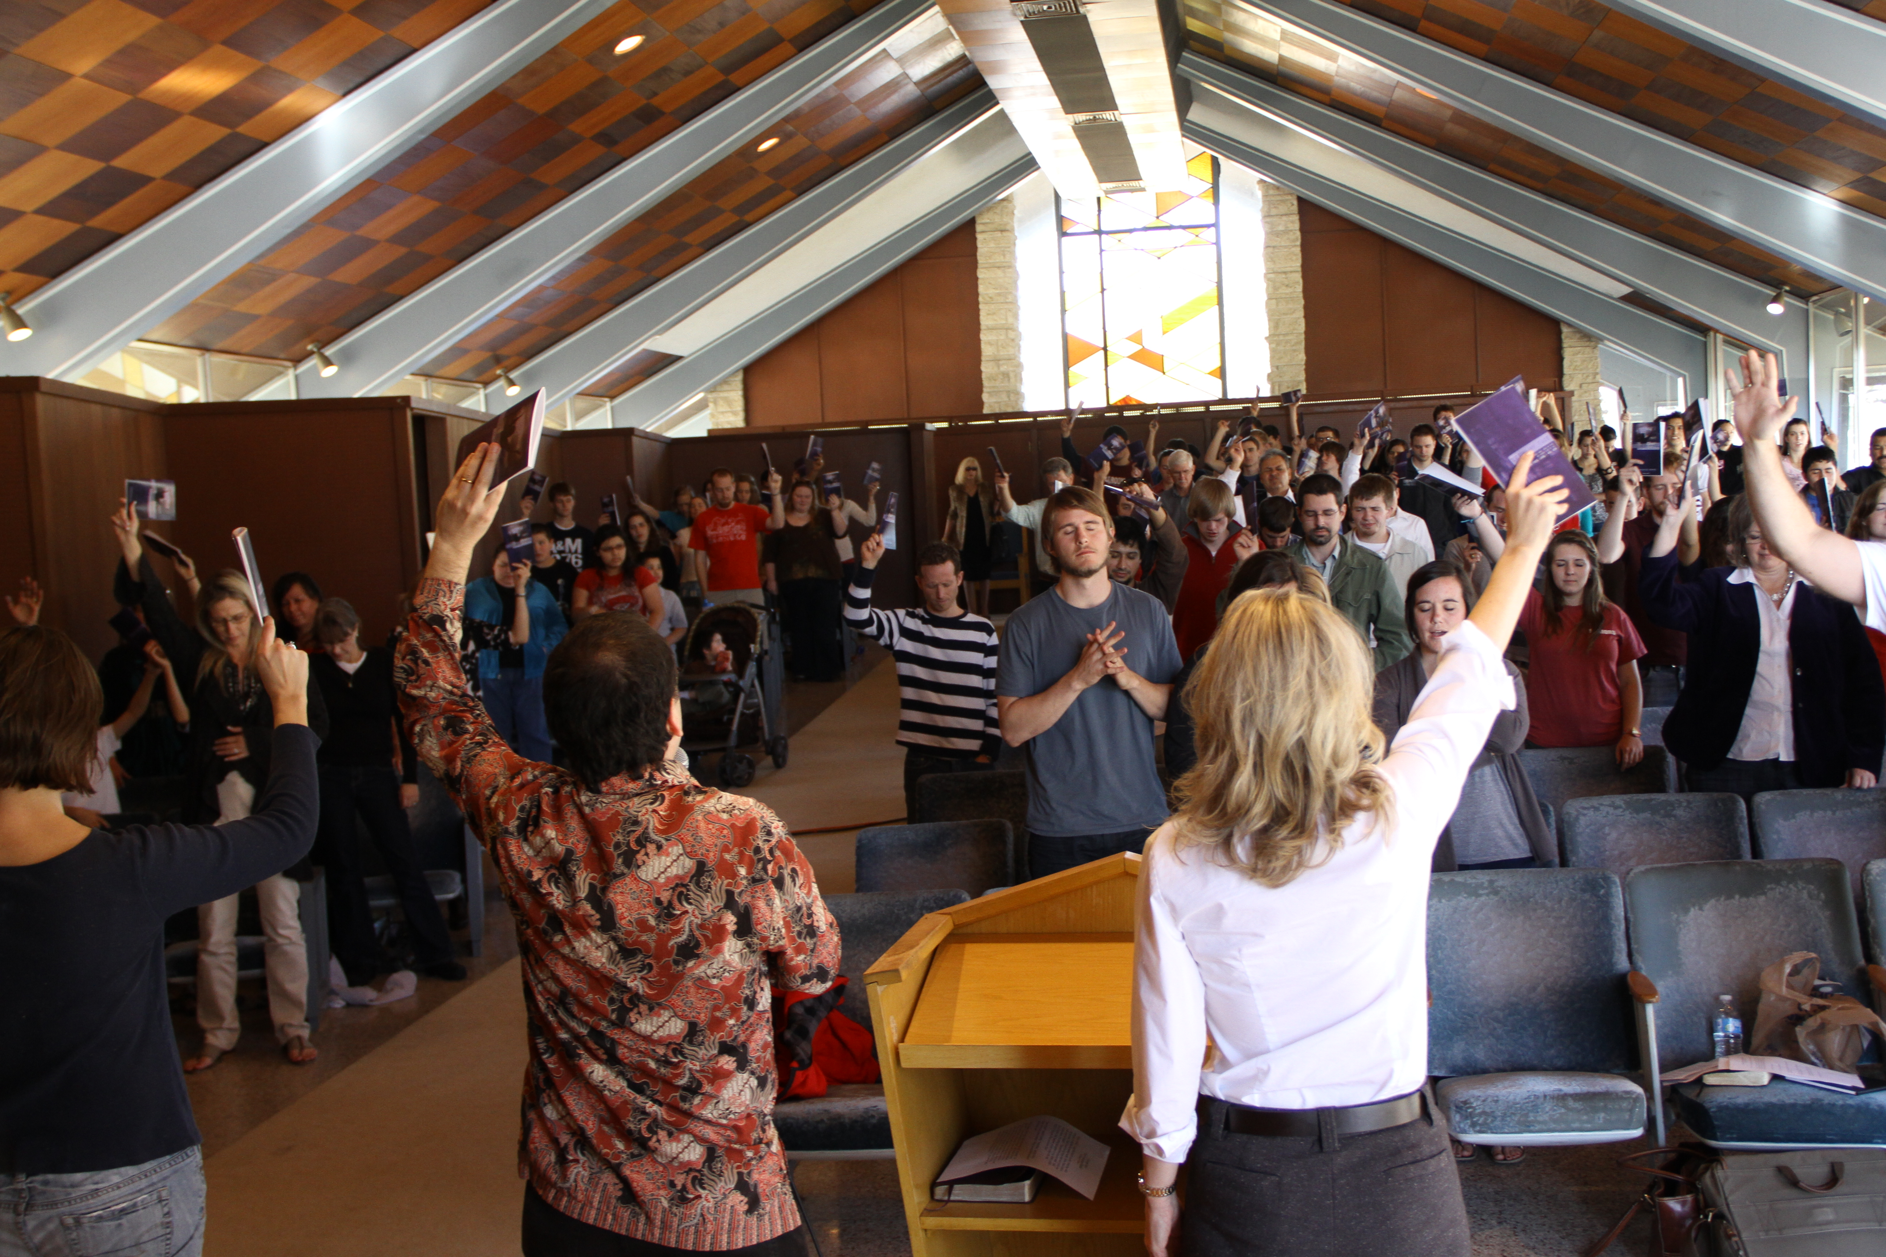
We believe this is a stake in the ground for a broader consecration on this campus and even other campuses in our nation next fall. Doors are already opening to other ministries at A & M and other universities – Jesus wants to consecrate this generation in radical devotion and prepare them for a spiritual revolution unto transforming revival in our nation!

Pray the Lord gathers, ignites and gives grace to their hearts as they begin their “exodus” from captivity into restored intimacy with Jesus!
I also had the joy of meeting with students and sharing the vision of transforming revival with them. They are so hungry for God to move on their campus! I told stories and shared for 3 hours!

We are planning a seminar on the campus following the consecration process to teach important principles of revival and spiritual revolution to help them transition from the Divine Experiment to a lifestyle of radical devotion!

Revival Book Update!

The Lord continues to open doors for our new book “Revival”. We are getting very encouraging responses from leaders and hungry believers alike. The book will go into its second printing this spring. We are encouraged to know this important message is stirring faith and igniting hunger for revival in our nation! Please agree with us that the Lord will open many doors to this faith-filled message!

What some national leaders are saying in response to reading the book:

Wes & Rhonda at book launch party

This is indeed a remarkable book! When I first picked it up rather nonchalantly and began to read it I was gripped by its multiple significance of historical dynamic, experiential potential and transformational possibility. My path converged with this work at a time when God was speaking to me about the whole revival component and its relevance to our present global crisis. Revival, of God's kind, is the only hope of this troubled, turbulent planet and will soon appear on our screen in a new format, the powerful presence of God. Thank you, Rhonda and Wes for this contribution!

Jack Taylor, President
Dimensions Ministries, Melbourne FL

I am genuinely awed by “Revival” and the beauty in which you present the subject. I have been in ordained ministry more than 60 years and this book threw new fire–new oil–new power–on my hunger for a true visitation of the Holy Spirit. Our world is in desperate need for the church to come alive! We must experience revival or humanity perishes! I read this book like I was hearing these truths for the first time–and I have been an ardent lover of revival for decades.

I fully expect the Word, Spirit, Power, conferences which R.T. Kendall, Jack Taylor, and I conduct to experience new life, new glory, and new power, because of this book. More importantly, I pray its impact will be felt worldwide. “Come quickly, Lord Jesus!”

Charles Carrin, Charles Carrin Ministries

Upcoming Ministry Events

Divine Experiment Celebration Texas A & M University
Texas – March 5th – 6th

The first week of March our team will return to Texas A & M for their Celebration service at the conclusion of the “Face to Face” consecration. We will gather with hundreds of students and other participants and share all the Lord has done in their midst during the 21 days! We will rejoice over miracles in their hearts, lives, families, bodies, finances and then worship the Lord for His goodness!

Transformation Leadership Retreat - Seattle – March 7th – 12

I will be spending the first week of March at a retreat with George Otis, Jr. and a handful of other transformation leaders for fellowship and to plan the “Journey to Transformation” seminar series that will be made available to communities next fall. Please pray for this important time! Leaders from the transformed community in Kentucky will be with us along with dear friends from Canada, Jamaica and several other places. We need wisdom to take these principles together as a team to communities longing for transforming revival!

National Leadership Consultation on Evangelism
Orlando – April 4th – 6th

I have been invited to serve on the planning team to facilitate a leadership consultation on Reaching/Transforming U.S. and global Cities. This is part of the Mission America Coalition/ US Lausanne Committee’s National Leadership Consultation on Evangelism in the U.S. and the World being held in Orlando this year. This important congress was initiated by Billy Graham in Lausanne Switzerland in 1974 to seek ministry collaboration for fulfilling world evangelization.

I have also been invited as an author to promote our books at the event and interact with leaders regarding the message of our ministry. This is an honor and special opportunity to promote presence-based transformation and ignite fire for revival! I will have a unique opportunity to influence leaders of national networks in our nation. Pray for divine appointments, favor and wisdom!

Team News

Following a season of great transition in his life after losing his wife Jane in October, Wes Adams has decided to step out of Fusion Ministries in an official capacity and go on staff at the Int’l House of Prayer. He has a desire to teach more in the Bible School and feels to connect there in a deeper way for the next season of his life and ministry.

While this was a difficult decision for us to process, we know it’s the Lord and believe He has the best in store for all of us. Wes will remain very connected to our team and Fusion Ministries – his heart is as passionate about transforming revival as ever! The Kingdom is built on relationship, not on structure or organizational charts, so we know that what the Lord has connected with Wes over the past many years will continue to produce fruit and life in us and through us in the season ahead.

Prayer Requests

Please keep us in your prayers as we step out into some new opportunities focusing on University Campuses, strategizing for the Transformation seminars with George and participating in the Mission America/Lausanne Congress.

Thank you for your prayer and financial support, if we ever needed you to sow into the ministry it’s now! We have some awesome doors opening to the message of consecration and transforming revival at a national level but these are not income producing activities for us. We are stepping out in faith!

We are still under-funded by $3,000 each month, which puts tremendous pressure on the ministry. Would you prayerfully consider becoming a ministry partner with Fusion and sowing into the Kingdom activity the Lord has set before us?

Contributions are tax-deductible and can be sent to:

Fusion Ministries, Inc.
721 Main Street, Suite 105, Grandview, MO 64030

Website: www.Fusionministry.com
Blog: Fusion4revolution.blogspot.com

Fusion Ministries, Inc. is now on Facebook!

